31/10/2015﻿
Our Homage to our beloved & respectable Leader SMT. Indra Gandhi.﻿
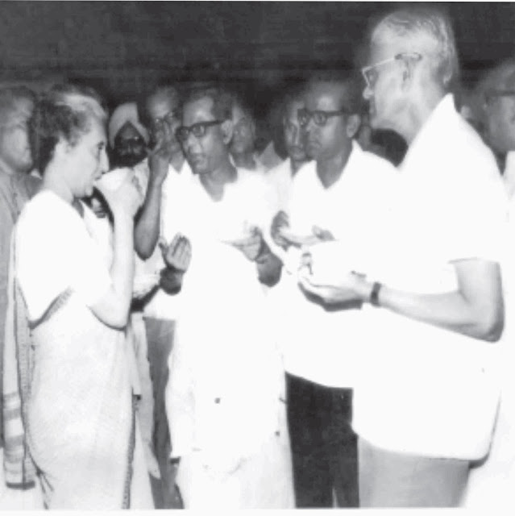SMT.Indra Gandhi taking cup of Tea with our KR. During Federal Congress of FNPTO﻿
30/10/2015
1)G.D.S.Hunger Fast A.P& Tamilnadu Circles photosClick here to see the Photos.
2)Letter-Writing Competition winner honoured in Berne
Click the above link to see the detail
28/10/2015

1)SB Order No. 15/2015 Mandatory Opening of Savings Account.﻿Click here to see above in detail﻿

2)Festival Advance for Government Employees Hiked to Rs 10,000
MUMBAI: Keeping in view guidelines of the Centre, the Maharashtra government has decided to increase the festival advance of non-gazetted employees to Rs 10,000.
The advance, which was earlier Rs 5,000, will cover nine major festivals - Diwali, Ramzan Id, Christmas, Parsi New Year, Rosh Hoshnaa (Jewish new year), Buddha Jayanti, Independence Day, Republic Day and Sanvatsari (last day of Jain's 'Paryushan).
"Non-gazetted state government employees will now get festival advance of Rs 10,000 for nine major festivals. The limit earlier was Rs 5,000. Finance Minister Sudhir Mungantiwar has taken this decision keeping the guidelines of the Central government in mind," an official from the state finance department said.
A Government Resolution (GR) in this regard has also been issued by the finance department on October 18.
"As per the GR, non-gazetted state government employees having pay band of Rs 4,800 or less will get this benefit," the official said.
﻿
26/10/2015
Hunger fast on 28/10/2015﻿
﻿FNPO affiliated union NUGDS decided to go on a day long hunger strike on 28/10/2015 in front of Circle office across the nation demanding
a) Inclusion of GDS issues in the terms of reference of seventh CPC
b) Grant of civil servant status to GDS.
i)Letter send by the NUGDS General Secretary.
ii)Letter send by SG FNPO to the Secretary
Clcik the above link to the letters.
FNPO affiliated unions circle secretaries are requested to cooperate with NUGDS colleagues to organize the hunger strike and make the programme success.﻿

2)No interviews for non-gazetted government jobs:﻿
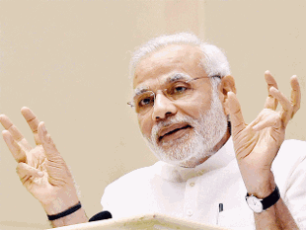﻿
There will be no more interviews for non-gazetted government posts for lower posts from 2016, Prime Minister Narendra Modi announced on Sunday.
Making the announcement Modi in his monthly radio programme "Mann Ki Baat" sought to remind listeners about his Independence Day address, when he had said that interviews should be done away with for lower posts.
"The process is almost complete... There will be no interviews for non-gazetted government jobs for group D, C, and B," Modi said.
"It will be implemented from January 1, 2016. We did not want to stop the ongoing process," he said
﻿
25/10/2015
Parliamentary Committee of Welfare of Other Backward Classes held on 14.10.2015.The Hon'ble Chairman and other Hon'ble Members of the Committee expressed dissatisfaction over low representation of OBCs in Central Government services and directed DoP&T to collect data sought by NCBC and submit to the Committee urgently.
CLICK HERE THIS LINK TO SEE ABOVE
﻿ 2)Government plans to focus on financial literacy; postmen to tutor rural India on banking system.
Click above link to see details

Government plans to focus on financial literacy; postmen to tutor rural India on banking system
By Dheeraj Tiwari, ET Bureau | 24 Oct, 2015, 07.14AM IST
Post a Comment
READ MORE ON » rural india | Postal department | India Post | financial literacy

Read more at:
http://economictimes.indiatimes.com/articleshow/49512186.cms?utm_source=contentofinterest&utm_medium=text&utm_campaign=cppst
﻿
23/10/2015
10th Federal congress Invitation.﻿
Clcik the above link to see invitation,
22/10/2015
Happy Navratri﻿﻿
﻿
21/10/2015
The Cabinet is expected to deliberate and consider a bill to amend the Payment of Bonus Act, 1965 today. Click here to see above in detail﻿﻿﻿
20/10/2015
1)Muharram P0 Holiday changed in Tamilnadu ﻿Click here to see above in detail﻿
2)FNPO affiliated union NUGDS decided to go on a day long hunger strike on 28/10/2015 in front of Circle office across the nation demanding
a) Inclusion of GDS issues in the terms of reference of seventh CPC
b) Grant of civil servant status to GDS.
i)Letter send by the NUGDS General Secretary.
ii)Letter send by SG FNPO to the Secretary
Clcik the above link to the letters.
FNPO affiliated unions circle secretaries are requested to cooperate with NUGDS colleagues to organize the hunger strike and make the programme success.
2)Shri N.Balasubrmanian was passed ﻿away
﻿
We regret to inform that NFPE P-3 EX Tamilnadu Circle Secretary Shri N.Balasubrmanian was passed away. FNPO convey its condolence to his family members and his followers﻿.

3)How to know your Roll number, date and venue of PA/ SA Exam 2015

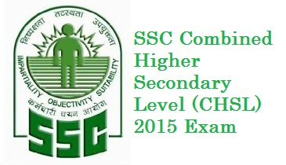
Click Here to know the roll number , date and venue of the Combined Higher Secondary Level Examination 2015 (PA/SA exam) being conducted by Staff Selection Commission on 01.11.2015 and 15.11.2015.
19/10/2015

Govt to bring more workers under bonus ambit
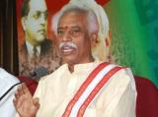Workforce of the country has another reason to cheer in this festive season as the Narendra Modi-led government is set to promulgate an ordinance to amend Payments of Bonus Act 1965 to make more employees eligible for annual bonus.
According to the proposal, those earning up to Rs 21,000 (basic + DA) a month will now be eligible bonus. This would be a steep jump from the current ceiling of Rs 10,000 (basic + DA) per month.
The Election Commission has approved the Labour Ministry’s proposal and the Union Cabinet is likely to take up the issue on promulgating ordinance next week. From this year onwards, bonus will be linked to minimum wages. The government is in the process of revising the minimum wages, a senior official in the Ministry of Labour told Deccan Herald.
In a recent meeting with trade unions and the ministry, the government agreed to amend the Bonus Act by enhancing the eligibility ceiling under section 2(13) of the Act from Rs 10,000 per month to Rs 21,000 month.
It also agreed to calculate ceiling under section 12 from Rs 3,500 per month to Rs 7,000 per month, or the minimum wage notified by the government for the category of employment, whichever is higher, an official in the Ministry told Deccan Herald.
Sources said despite reservations by the industry representatives on the revised ceilings, the government has decided to go ahead with the proposal.
Trade unions
Though the trade unions demanded the abolition on ceiling on payment of bonus due to rising inflation, the government rejected it.
﻿

Allocation of candidates, nominated by Staff India Post nominated by Staff Selection Commission for appointment as Stenographer Grade - II Posts on the basis of Stenographer 'C'& 'D'Examination, 2013 & 2014, to various postal Circles.

Click above link to see detail.
﻿
2)Wal-Mart paid millions of dollars in bribes in India: Report
America’s multinational retail corporation Wal-Mart is suspected to have paid bribes worth millions of dollars in India, according to a media report.In a major report, The Wall Street Journal said Wal-Mart’s “...Click here
Read more »
﻿
18/10/2015

1)Postal Bank to Open in Dec﻿
2)PENSION FUND REGULATORY AND DEVELOPMENT AUTHORITY﻿Click here to see above in detail.
17/10/2015

1)Court orders against DOPPW Govt. of India Instructions on service matters
﻿2)Fixation of pay on promotion of pre-revised merged pay scales between 1.1.2006 and date of notification of CCS(RP)Rules 2008 – Clarification orders issued by Finance Ministry on 16.102.015
Cases of promotion taking place in the pre-revised pay structure between 1.1.2006 and the date of notification of CCS (RP) Rules, 2008 and the subsequent merger of the pre-revised pay scales of the promotional and the feeder posts in a common Grade – Fixation of Pay – RegardingClick here to see above in detail.﻿
16/10/2015
20th All india Conference
National Union of RMS & MMS MAIL GUARD & MTS .20 ^{h} All india Conference was held at APJ ABDULKALAM Nagar ,in Kandukuri Kalyanamandapam, Gandhi nagar, Vijayawada from 1310/2015to16/10/2015.
On 13/10/2015 the conference was inaugurated by SGFNPO. General secretaries of FNPO afilated unions greated the conference .
On 14/10/2015 the subject committee was held Shri P.D.Bhavikar preside the meeting Shri N.Ramppa presented the Biennial report for the period of 2013to 2015 . Shri S.Sridharan presented Audited Accounts both are adopted by the house. Thereafter NUR-IV Circle secretaries spoke on the problems of their circle.
On 15/10/2015 the following office bearers were elected S/SHRI P.D.Bhavikar, N.Rmappa, S.Sridharan were elected as president, General Secretary& Secretary Finance respectively .
Shri I.U dhya Baskar Rao and his team made arrangements for boarding and lodging.
FNPO Wishes all the new office bearers of NURIV success in their endeavors.
2)Public Servants (Furnishing of Information and Annual Return of Assets and Liabilities and the Limits for Exemption of Assets in Filing Returns) Third Amendment Rules, 2015Click here to see above in detail.﻿
15/10/2015
1)Shri Narendra Modi Ji, Prime Minister, formally released the commemorative postage stamp on former President of India, Dr. Kalam, at DRDO Bhavan, New Delhi, today.
2)50 mail runners reached General Post Office, George Town on the occasion of celebrating National Postal Week.﻿
3)Modification of Central Government Pensioners life certificate Format for Revised Life Certificate – Modification in Life Certificate (Annexure XVII).
4)Air Travel on LTC once in Ten Years to visit foreign countries – WB State Govt Orders issued on 9.10.2015
5) Claiming of medical expenditure for tax purposes made easy.
6) Survival of postal service hinges on ability to quickly change, innovate, UN highlights on World Day
Click here to see above in detail.﻿﻿﻿
﻿
13/10/2015
Happy Navratri﻿
﻿﻿

12/10/2015
1)What CG Employees can Expect from the 7th Pay Commission
2)Declaration of Assets and Liabilities under Lokpal : Date extended
3)Enhancement of the ceiling of bonusClick here to see the details.﻿﻿
08/10/2015

1)SC refers Aadhaar privacy issue to Constitution Bench.
2)DEPARTMENT CAN NOT MAKE RECOVERY AFTER RETIREMENT - JABALPUR CAT ORDER﻿
﻿Click here to see the details.﻿
07/10/2015
1) 60 DAYS BONUS- Rs.3500/- CEILING PRODUCTIVITY LINKED BONUS FOR THE YEAR 2014-2015﻿ ORDER ISSUED.
Click here to see the order.﻿

2) World Post Day.
﻿
3)Meeting of the National Council (JCM) Staff side under the Joint Chairmanship of JS(AV), DOP&T to discuss the issues raised in the Charter of Demands by the Staff Side.
4)DA order for GDS. ﻿Click here to see the details.﻿
06/10/2015
15th AIC OF NUGDS.
15th AIC of NUGDS was held at Parajapathi lodge Kharagpur West Bengal from 01/10/2015 to 3/10/15 .
On 02/10/2015 before open session leaders & General secretaries pay the respect to Our father of the Nation &martyrs. The open session was presided by the Chairmen Reception committee Shri Debasis Chowdhury, Hon Member of the Parliament Subhendru adhikari ingrate the 15th AIC of NUGDS . S/Shri D.Thegarajan,P.U.Muralidharan , D.kishan rao ,B.Shivakumar & shivaji addressed the open session.
On 03/10/2015 Shri P.U Murlidharan placed Activities report and B.S.Venu placed Finance report both were adopted by the house. More than 40 representatives addressed the Delegate session.
In the conference S/Shri CH Lakshmi Naryanan, P.U. Muralidharan & B.S.Venu were elected as President, General Secretary Finance Secretary respectively.
Shri Rjat s.das Secretary Reception committee & his team made an excellent arrangements for Lodging & Boarding within a short period. FNPO wishes all the office new bearers of NUGDS for the success in their endeavors﻿
05/10/2015

Seventh Pay Commission will be mindful of fiscal concerns: Finance ministryClick here to see the details.﻿﻿
04/10/2015
Government to register Postal Bank by year end.﻿
Click here to see the details.﻿﻿﻿
02/10/2015

﻿01/10/2015
SG FNPO Programme﻿
01/10/2015 to 05/10/2015 Kolkatta. (AIC NUGDS)
13/10/2015 to 15/10/2015 Vijayawada. (AIC NUR/4)﻿

﻿

