30/05/2014﻿
Today SGFNPO and SGNFPE discussed the federation memorandum to be submitted to the 7th CPC
On 29.05.14 SGFNPO along with Shri D KISHAN RAO and TN Rahate met Secretary, Department of Posts and discussed the outcome of preliminary interaction meeting held with chairman and members of the 7th Pay Commission. Further the team also conveyed retirement wishes to Secretary(Posts).
After the meeting Shri D KISHAN RAO and SGFNPO met DDG(SR) Director(staff) & Director (Mails). Discussed issues related to decreased mail traffic with Director (Mails) and other issues with Director (staff). Details will be posted in our sentinel.

Extension of last date of submission of Memoranda to 7th Pay Commission

SEVENTH CENTRAL PAY COMMISSION
GOVERNMENT OF INDIA

Extension of last date of submission of Memoranda
The Seventh Central Pay Commission has invited all associations, unions, institutions, other organizations and interested individuals to send memoranda containing their views on the Terms of Reference of the Commission. These memoranda were to be submitted by end of May, 2014, as indicated in the letter dated 29.4.2014/Public Notice that appeared on 4.5.2014.
The Commission has received requests from several quarters that the last date for submission of the memoranda be extended. The matter has been duly considered and it has now been decided by the Commission to extend the last date of submission of memoranda from 31st May, 2014 to 31st July, 2014
SOURCE : 7THCPC.INDIA.GOV.IN
﻿29/05/2014
﻿Preliminary Interaction meeting with Chairman and members of Pay Commission:
Today FNPO delegation consisting of General Secretaries NAPEC , General Secretary, PM&MTS, SGFNPO and R.Ravichandran participated in the meeting. During our meeting we presented that India Post is fully computerized and IT enabled and Justification for higher Pay Scale on account of computerization, Savings Bank, Life Insurance and Money Remittance, 100% IT driven on completion of IT project. And multifarious duties. Further we mentioned that Post Man touching every corner of the country. PO is a multipurpose delivery for central and state government schemes like Savings Schemes Payment, MGNREGA & DBT. Demand for higher scales of other cadres in DOP has been emphasized. However we did not mention minimum scale and grade pay. MACP anomalies were discussed. The details of the Power Point presentation are hereunder:
Click here to see the Power Point presentation﻿

28/05/2014
﻿Welcome to our Communication Minister﻿ Shri. Ravi Shankar Prasad﻿
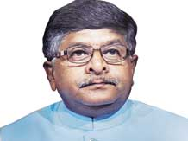
26/05/2014
Today, SG FNPO met JCM staff side leader Shri M. Ragavaiah, and discussed 7 th CPC related issues. ﻿
On 23.05.2014 and 24.05.2014 AIC, AIPAO (FNPO) was inaugurated by Shri T. N. Rahate, President FNPO. All the General Secretaries of FNPO affiliated Unions and SG FNPO greeted the conference. Shri O.P Khanna, re-elected as General Secretary. Shri L.K. Mathur, elected as President. Details of the conference will be published in our sentinel.
On 25.05.2014 Postal JCA meeting was held at NFPE Office. FNPO and NFPE affiliated General Secretaries participated in the meeting. The out come of the meeting is as follows:
1. Cadre wise memorandum will be submitted to the 7 CPC on 30.05.2014 by mail as well as in person.
2. Federations memorandum will be finalised after consultation with all General Secretaries of FNPO & NFPE affiliated unions in the 2nd week of June 2014.
3. Postal JCA decided to submit memorandum to the new communication Minister as well as new secretary Department of Post.
﻿24/05/2014
SG FNPO PROGRAMME
24.05.2014 --- Jaipur
25.05.2014 to 31.05.2014 – Delhi
01.06.2014 to 04.06.2014 --Tirupathi
﻿Why is Annual Increment denied to employees retiring in June?
Until 01.01.2006, the date of implementing employee’s annual increment was fixed on the basis of his/her date of appointment or promotion option. After the 6th CPC, it was decided that 1st July of each year would be the uniform date of implementation of annual increment for all Central Government employees.
Employees who are appointed after January 1st are not eligible for that year’s annual increment on July 1. They qualify for annual increment only the next year.
The revised pay rules said that “If an employee is on leave or is availing joining time on the 1st of July, the benefit of annual increment in pay will be drawn only from the date on which he resumes duty and not from the first of July. Each year, employees who retire in the month of June are not given the annual increment of the year since they do not report to work on 1st July. Only those employees who resume duty on July 1st are eligible to receive the annual increment. Or, the day they report back to work is taken as the date for implementing the annual increment. Since there are no possibilities for the retired employees to return to work, they are not considered as qualified to receive the annual increment.
The revised pay rules states that only those who have been receiving the same basic pay continuously for 6 months are considered as qualified for annual increment. According to the another rule of qualification for increment, the person should have complete one year in service after receiving the annual increment. Therefore, despite being qualified, these employees are denied their annual increment.
There is an order that states that those who retire on July 1st should complete the retirement formalities in the month of June.
Instead of strictly looking into such technicalities, it would be a nice gesture on the part of the Government to extend the benefits of annual increment to those senior employees too who retire from service in the month of June.
﻿

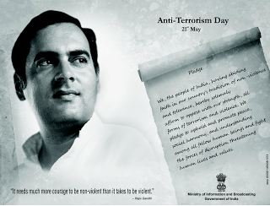
21/05/2014
7th Central Pay Commission invited Shri. D Theagarajan, Secretary General, FNPO for interaction on postal employees related issues on 29th May 2014 at 12 noon.
Details of the interaction will be posted in our website on 29th evening.
All our office bearers including our viewers are requested to send your views before 26th May 2014 to SG FNPO

20/05/2014

FNPO affiliated GS are requested to prepare your sectional memeorandum except the pay scale of basic cadre and promotional cadres. Pay scales can be finialised after the JCM staff side finalizes the mininum wage and other pay scales - SG FNPO

A new dawn for post﻿﻿
﻿
The UNI Post and Logistics world meeting is underway in Switzerland facing up to the challenges of the brave new world of post. Innovation and inequality are high on the agenda and the meeting will not shirk the big issues.
President Billy Hayes opened proceedings by evoking the spirit of British comedian Billy Bennett. “It’s the same the world over,” Hayes said, “It’s the rich who get the pleasure and the poor who get the blame. That’s what we’re here to address.”
UNI Global Union General Secretary Philip Jennings issued a rallying cry for the sector to fight “wave after wave of changes” hitting postal workers. “Deregulation, privitisation and bilateral trade agreements are all resulting in a demolition of postal services,” Jennings warned.
The UNI Chief said that the unstoppable rise in e-commerce and home delivery represented a huge opportunity for the postal sector and urged unions to stay on the front foot.
“You are the distribution network. You know how to do it. We must look at how we innovate. There will be growth and new opportunities, and postal workers will need to build on the trust they have in communities.”
“We need to keep the local networks alive by adapting our post boxes, post vans and investing in innovation.”
The 2015 ILO Conference will focus on the global supply chain and developing a new labour standard from the factory to the consumer. Postal and logistic workers are at the heart of this supply chain, Jennings said, and UNI Post and Logistics must help to drive the new agenda.
The UNI Post & Logistics World Meeting, taking place over two days at UNI Global Union headquarters in Nyon, Switzerland, will hold sessions on organising new workers and campaigns, defending universal postal services, innovation & E-Commerce as well examining ongoing threats to the sector.﻿
16/05/2014
7th Pay Commission calls for report on pay and allowances and other service conditions of Central Government Employees from all Secretaries of various Central Government Departments.
Click here to see the details﻿
15/05/2014
1)Fixed Medical Allowance to Central Government pensioners residing in areas not covered under CGHS
2) Childeren Education Allowance.
Click here to see the details.
13/05/2014
Fulfilling the global e-commerce promise
What is its impact on the postal industry? What do customers expect from e-retailers, delivery and payment services? What do merchants want from Posts? Watch the video on the UPU E-Commerce Forum!
[Click here to watch video
12/05/2014
1)National council staff side (JCM) request Oral evidence &extension time limit for submission of Memorandum .
No Banking job for the Postmen
Click here to read the above in detail﻿
10/05/2014
1)Arrangement for training of Liaison Officers for Scheduled Castes and Scheduled Tribes
2)List of Allowances & Advances increased by 25% due to DA touched to 100% with effect from 1.1.2014.
3)Final version of Reply to 7th CPC Questionnaire formulated by Staff Side JCM National Council
Click here to see the above in detail.﻿
08/05/2014
7th CPC Questionnaire - Reply given by JCM National Council (Staff Side)
No.NC-JCM-2014/ 7th CPC May, 2014
The Secretary,
7th Central Pay Commission,
New Delhi
Sub: - Reply to Questionnaire

Respected Madam,
We are enclosing herewith reply to Questionnaire on behalf of National Council (Staff Side) JCM for kind consideration of the Commission.
With regards,
Yours faithfully,
(Shiva Gopal Mishra)
Secretary
Click here to see the Reply given by JCM National Council (Staff Side)
2)Simplification of pension procedure - submission of undertaking by retiring Government servant along with pension papers - reg.
Click here to see the details.
3) Temporary deputation to Hajj.
Click here to see instruction to Circles
07/05/2014
1)7th Pay Commission Issued Public Notice to invite Suggestion
2) Revision of Pension of Pre-2006 Pensioners with effect from 1st January 2006 – Curative Petition before Hon’ble Supreme Court dismissed ﻿.
3) BSNL 20% Discount for Central Government Employees – Regularization of the discount scheme at a reduced 10% ﻿﻿
Click here to see details on above sujectes
05/05/2014
GLORIOUS SILVER JUBILEE CONFERENCE OF FNPO AFFILIATES KERALA CIRCLE
The 25th circle conferences of National Unions affiliated to FNPO started at O.T.Bhaskaran nager, Aban Auditorium, Pathanamthitta on 4th May 2014.The Flag hoisting was done at 0900 AM and the INTUC flag was hosted by Sri A.shamshuddin, District President, INTUC and FNPO flag by Sri Johnson D Avokkaran, FNPO convenor. The Grand Open session started at 1000 AM inaugurated by Sri Ramesh Chennithala, Honorable Minister for Home, Kerala by lighting the lamp. The key note address was delivered by Sri Anto Anthony, Honourable MP, Pathanamthitta.
The prominent speakers who addressed the open session were S/S A.Shamshuddin, President INTUC, D.Theagarajan, SG,FNPO, D.Kishan Rao General Secretary, NAPEC, P.U.Muralidharan, GS,NUGDS, K.Sivadasn General Secretary, Civil wing, Johnson Avokkaran CS, NAPEC, D.Christ Das, N.V.Vinod Circle secretaries, K.J.Raphy, CGE&W congress, Kerala. Vote of thanks by Sri Sam Daniel, Ex secretary NUPEC.
The women conference started in the Afternoon. Smt Anu-P-Baby Welcomed the Participants. The conference was presided over by Smt.Bhagya Sree, Chair person FNPO womens wing. The conference was inaugurated by Smt. Stella Thomas, Dt.Secretary mahila Congress, Pathanamitta. Vote of Thanks by Jibi Mariyam Philiph. The prominence of the meetings was TWO DISTINGUISHED GUESTS Smt Chanthi veda Singhe and Smt. Irosha karannagoda participated from UNI-Apro, Srilanka on our invitation.
A seminar on MODERNISATION OF DEPARTMENT OF POSTS-POST BANK OF INDIA was held in the afternoon. Sri C.Sivadasan Pilaai, Supdt. of post offices, Patahnamthitta, presented the subject. S/S D.Theagarajan, SG,FNPO D.Kishan Rao GS, P.U.Muralidharan, GS, R.R.pillai Rtd SSPOs, R.Ravindranathan, Retd.SSPOs, M.Harisudha, GS, Stenographers association participated in the discussion. Sri Johnson Avokkaran coordinated.
At 0430 PM a colourful procession was organised in the streets of Pathanamthitta with thunderous slogans and the public meeting was held .The subjects committees are in session.
The pensioners conference was held at the same venue Sri T.Joy Ex circle president of NAPEC Presided. Sri O.K.Diwakaran, EX AGS NAPEC ,& convenor FNPO Circle Secretary Kerala inaugurated and convenor of Adhoc committe of Postal & RMS pensioners Association. S/S G.Sivaprasad, Ex Vice president, Pookkunjan R.Sasundram, M.n.Kuttappan Pillai were spoke on the occassion. The conference resolved to request the 7th CPC to implement one pension to one rank one just like defense personnel
03/05/2014
SG FNPO PROGRAMME
﻿03.05.20.14 to 06.05.2014—Kerala
24.05.2014 --- Jaipur
25.05.2014 to 26.05.14 -- Delhi
﻿02/05/2014

National Council JCM Meeting to discuss about 7th Pay Commission
1) In a letter dated 9-4-2014, the Secretary, Staff Side, National Council JCM submitted an agenda comprising 09 points to the Chairman, Standing Committee, National Council (JCM), for discussion in the next standing committee meeting.
Accordingly the next meeting of the Standing Committee of the National Council JCM is scheduled to be held under the chairmanship of Secretary (P) on 7th May 2014 at 11.00 AM in the conference Hall, North Block, New Delhi. Agenda points submitted by the staff side will be discussed in this Meeting.
According to the sources close to JCM National Council, a preliminary Staff Side meeting is supposed to be held on 6th May 2014 in the office of National Council (Staff Side) – JCM, to discuss the Agenda items, Draft Reply to 7th CPC Questionnaire
So it is expected that discussion on important points will take place in these meetings and the outcome of these meetings will be the deciding factors of the path in which 7th pay commission should travel to determine the pay structure and service matters of central government employees. Draft Reply to the 7th CPC questionnaire will be be finalised in the staff side meeting and it will play a key role in the 7th Pay Commission as it is the view of 3 million central government employees
The agenda points to be discussed in the above said meeting is already circulated to all the Standing Committee Members of National Council JCM by Shri. Shiva Gopal Mishra, Secretary, Staff Side, National Council JCM
Click to See : Agenda Points submitted by Staff side for Discussion﻿
2) Clarification on definition of Hometown LTC ﻿click here
3)Glimpses of Coaching Class for PA/SA Aspirants conducted at St. Thomas College, Thrissur by FNPO﻿ Click here to view photo
01/05/2014
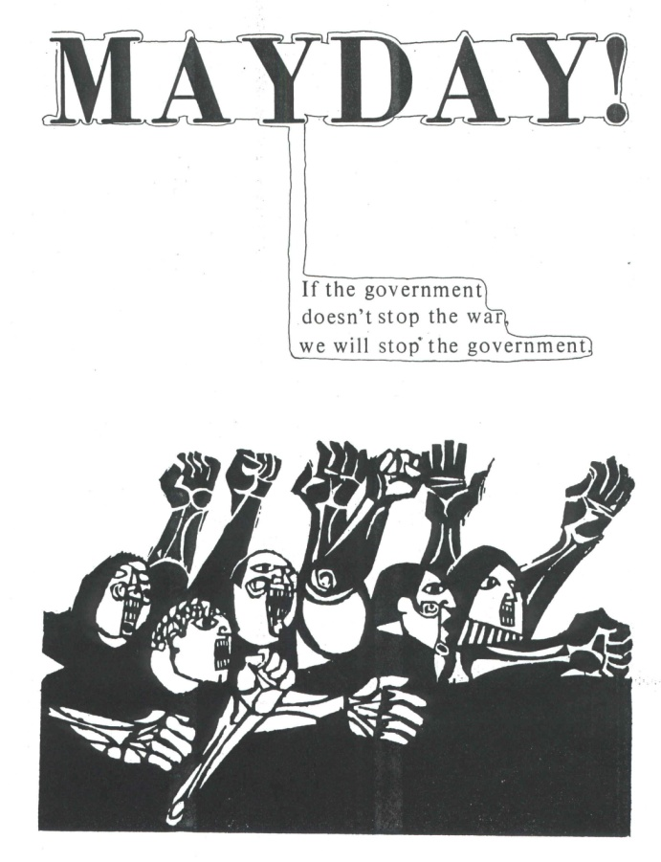
7th CPC Questionnaire & Memorandum.
Dear colleagues,
May day greeting to all,
Your are aware that we have to submit reply to the questionnaire on 10th May , 2014 . Staff side (FNPO & NFPE) has decided to submit common reply to the questionnaire .
As regards Memorandum , National council will formulate the principles based on that NFPE & FNPO will submit memorandum on Postal issues.
FNPO General secretaries are requested to prepare memorandum before 20th May, 2014 and submit in JCA general secretaries meeting on 25th May 2014.
Thereafter common memorandum will be prepared cadre wise.
Now pay commission fixed last date of submission memorandum is 30th June 2014.
Please send your suggestions to your general secretary before 20th May 2014.
Click here to see the letter received from the Pay commission Secretary.
﻿

