27/11/10 Latest Govt.orders
1) SENIORITY - Consolidated orders on...
2) Redesignating erstwhile Group ‘D’ employees as Multi Tasking Staff Group ‘C’ and their revised duties.
3) Streamlining of functioning of CGHS dispensaries.
Click here to see the orders
26/11/10
NEWS IN BRIEF
S.G.FN.P.O contacted DDG(East) and enquire about the convening of CADRE RESTRUCTURING COMMITTEE MEETING . The DDG replied that the formal meeting will be conducted shortly. Invitation will be sent to committee members as per the procedures.
POSTMEN RELATED ISSUES
Formal meeting will be held shortly .The DDG(East) will inform the date of the meeting to committee members and observers.
Mail Network Optimization.
Our Federation totally opposes the present changes in the Speed Post Network. We request R-3 circle /Division/branch/well-wishers to send their views to the CHQ / Federation in this regard.
P IV Circle conferences
Tamil nadu PIV Circle conference will be held from 28/11/10 to 30/11/10 .at Tuticorin The SG FNPO will attend the conference. WestBengal PIV circle conference will be held on the same dates (28/11/10to30/11/10) The GS T.N.Rahate will attend the conference.
HSG I Recruitment Rules.
The Department may issue revised Recruitment Rules for HSG I before 10th December 2010 .
Norms for additional duties to GDS: Establishment Branch has finalized norms for additional duties to GDS .It is about issue.
OSA:
Till date the Department has not been sent to the finance ministry for approval.
Revised Recruitment Rules for the MTS:
Still the Department has not received the revised recruitment rules once it is received Department will issue order to recruitment the MTS in PO & RMS.
24/11/10
Attention to the Circle/Division/Branch Secretaries of NAPEC- Department issued order regarding Introduction of Postmaster Cadre in Postal Wing. Read and send your suggestions to Federation and CHQ ,NAPEC.
Click here to see the order
1) Placement of seniors at par with their juniors under TBOP/BCR Schemes – clarifications regarding.
2) REVIEW OF INSTRUCTIONS ON ENGAGEMENT OF CASUAL LABOURERS INTHELIGHTOFTHEGUIDELINESONOUTSOURCING
3) 20th Meeting of the Postal Sports Board held at Chennai on 5th July, 2010-Follow up of action on the decision taken by the Board.
4) Study Leave for Fellowships offered by reputed Institutes
5) Departmental proceedings against Government Servants – consultation with the Union Public Service Commission for advice.
Click here to see the Govt. orders

23/11/10
Today the chairman Postal services Board conducted a meeting on the following subjects.
i)Technological developments in Department of Posts .
ii)Mail Optimization
The General Secretaries of FNPO and NFPE affiliated unions and Secretary Generals of FNPO ,NFPE and BPEF participated in the meeting.
Technological developments in Department of Posts : Our Federation welcome the move of the Department However we did not give any consent doubts which were raised by our Federation was clarified by the Member (Tech). According to the presentation there may be a big changes in the Post Offices.
Mail Optimization: We register our strong protest to reduce the number of sorting centers (SPC) from 352 to 89. If this is implemented there will be delay in mails by at least 48 hours. We did not know whether the Department will agree with us or not.
On the above TWO subjects we submitted our letters.
Click here to see the letters.
Please click here to see the Power Point Presentation on Mail optimization.

22/11/2010
Today SGFNPO and GSNUPEC met the following officers.
1. Chairman Postal Board 2.Member (Technology) 3.Member (Training) 4.DDG (P)
Recruitment of PA/SA
Our Federation whole heartdly thanked the Chairman for the transparent recruitment system compared to previous occasion.
Training: Maxmum trainess will be accommodated in the training classes. Morning & Evening session will be conducted, rest of the trainees will be allowed to work in the non – sensitive post (back office other than counters till the training is completed).
The Dept is trying to get local Engineering colleges for the purpose of training. Suitable instructions have been issued to all the Head of Circle.
IA applicant: The Directorate has received the name of IA applicants from the apex court and the same has been forwarded to Tamilnadu circle to check whether the applicants are still working.As soon as reply is received orders will be issued
20/11/10
NEWS IN NUT SHELL
The Dept. of Posts is to discuss the following subjects to the General Secretaries and Secretary Generals ,in the presence of the Secretary, Dept. of Posts, Member (P) , Member ( O ) and Member ( Technology) on 23.11.10 :
i)Technological developments in Department of posts
ii)Mail Optimization.
iii)Preparation of strategy and strategic plans for Government.
Details will be posted in our website after the meeting.
DEPARTMENTAL COUNCIL
The exact date of the meeting has not yet been finalized by the Department to discuss the remaining items of the Agenda. The meeting may be convened shortly.
REVISION OF WAGES OF CASUAL LABOURERS AND PART TIME CONTINGENT STAFF
It is learnt that old file was traced out by the Department in connection with payment of arrears to the above staff paid on the recommendations of the V pay commission. This file was sought by the Department of Personnel. We hope the Department will take necessary formalities for paying arrears of pay based on the VI pay commission recommendations to the above staff.
18/11/10
1)80% of post offices losing money, Oct, 10, 2010.
2) Govt fully cognizant of modernizing postal networks: President, Oct9, 2010.
3)U.S. Postal Service fails at delivering good customer service. Oct 9, 2010.
4)Postal dept to launch website for job seekers. Oct 9, 2010.
5)Postal Service Focuses on Energy Conservation. Oct 7, 2010.
6)Vernon carriers need clear access to deliver, Postal Service says. Oct 8, 2010.
Click here to see the details
17/11/10
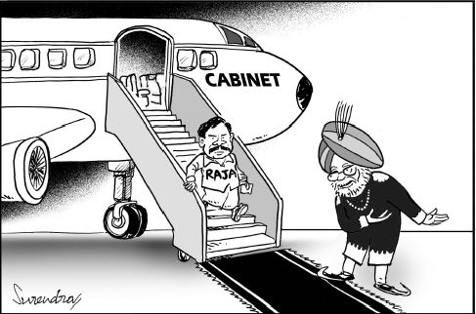
courtesy : The Hindu

17/11/2010
RMS SENTINEL NOVEMBER -2010 avialable in RMS Sentinel page - All are requested to read.
16/11/10
How Raja steam-rolled a woman secretary
New Delhi: In his dogged determination to grant 2G spectrum licences to his preferred firms for a song, former telecom minister A Raja had no qualms in castigating bureaucrats who wanted to play by the rules. While former telecom secretary D S Mathur's counsel was ignored by the minister and the then Trai chairman's views were not sought, he even tried to bring disgrace to another senior official by questioning her integrity in file notings.
Raja's aggressive behaviour virtually forced former member-finance in the Telecom Commission Manju Madhavan to take voluntary retirement after proceeding on leave in 2007. In a written note, Raja accused Madhavan of working "on behalf of vested interests". The language used by Raja and the posture adopted by him clearly bring out what the Comptroller and Auditor General's report and Mathur have said: the minister was adamant on granting licences on the terms and conditions which best suited him. When FE contacted her, Madhavan declined to speak on the matter, "Thanks for calling me but I don't want to speak on the matter," she said.
What was Madhavan's fault that she drew Raja's ire in a manner which is quite unbecoming for a minister when it comes to dealing with a senior official?
Madhavan had put up a note arguing that the rates at which the licences were being planned to be given should be revised as they did not reflect the current market dynamics. She had proposed three alternatives to the minister which would have fetched the government higher revenues.The then DoT secretary endorsed her views on the file.
"Since the rates have not been revised and the finance secretary has raised the issue, I am of the view that this issue should be examined in depth before any further steps are taken in this matter," Madhavan had said in her note on receipt of a letter from the then finance secretary, D Subbarao wherein concern was expressed that the licence fee was based on 2001 bids.Raja had wanted to give licences for a pan-India operation for Rs 1,651 crore, a rate discovered through auction of licences in 2001 and other officials, including Madhavan were opposing it. Reacting strongly to the proposal Raja noted in the file, "The matter of entry fee has been deliberated in the department several times in the light of various guidelines issued by the department and recommendations of Trai. And, accordingly a decision has been taken that entry fee need not be revised".Further admonishing the member-finance, he went on to state, "On the above lines, (the) secretary telecom has also replied to the finance secretary's letter. Member finance should have checked the facts with the secretary telecom before putting up the note on the file."Raja's anger did not stop at that and he went on to accuse Madhavan, "these type of continuous confusions observed on the file, whoever be the officer concerned, does not show any legitimacy and integrity but only their vested interests".
Making an even more caustic remark, Raja noted, "Concerned officers have neither up-to-date knowledge of unified access service licence (UASL) guidelines nor have bothered to go through the file".
In her note Madhavan had meticulously drawn up alternatives whereby the government would have conducted auctions for licences by keeping the 2001 price as the base price and allocating spectrum to the winners according to availability.
She had also stated that prior to any such auction a study should be taken to find out how much spectrum was available and what is the need of the existing operators for further growth and then only a holistic criteria be fixed for granting any fresh licence/spectrum. Soon after this, Madhavan went on leave and later sought voluntary retirement from service. Mathur also retired and with a new secretary Siddhartha Behura who signed the files Raja was able to grant the licences as per his wish on January 10, 2008. Behura had told FE on Sunday that he had no option but to implement the minister's decision.
Source: Financial Express

14/11/10
UNI Congress in Nagasaki comes to an exciting close - FNPO was represented by D.Theagarajan, D.Kishan Rao and P.U.Muralitharan
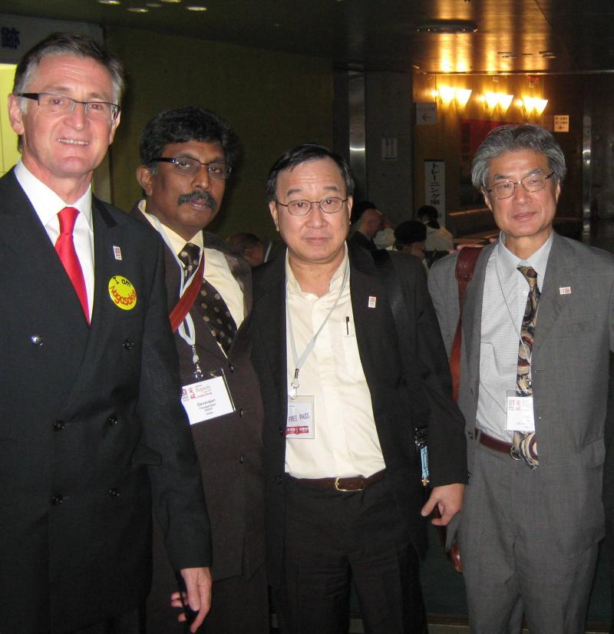
Short note on the conference:
The UNI World Congress finished with a bang of Japanese and African drums making a symbolic transition to Cape Town, South Africa, site of the UNI World Congress in 2014.
Congress delegates endorsed Breaking Through, the new plan for UNI to grow itself and its unions by focusing on organising workers and ensuring collective bargaining rights. The Congress also passed a host of other resolutions, including a new plan to ensure women hold at least 40 percent of every leadership structure in the organisation. The Congress also approved a new organising fund, to which affiliates can contribute to fund union organising work around the world.
Congress delegates elected a new president, Joe de Bruyn, a leader of Australian commerce union SDA. They reelected Philip Jennings as General Secretary.
“This UNI Global Union knows where it wants to go,” Jennings said in his closing address. “There is no time to lose. We are stronger together. This is a team effort. You elected me but you endorsed a team.”
Jennings said the team, in offices around the world, will work together on Breaking Through.
Jennings thanked the Japanese team for their “Brilliant Congress.”
“Please feel proud,” he said. “You could not have done better.”
Aside from all their work planning and organising the Congress, the Japanese host unions brought an army of young union member volunteers to Nagasaki who acted as guides, ambassadors, interpreters and all-around helpers for Congress attendees. The volunteers helped create a wonderful atmosphere at the Congress.
“To South Africa: 2014 is just around the corner,” Jennings said. “In Berlin, Chicago and Nagasaki the bar has been lifted. Together we will take the 2014 Congress to a new level again.
12/11/10
TECHNOLOGICAL DEVELOPMENTS IN DEPARTMENT OF POSTS-PRESENTATION TO THE STAFF SIDE ON 23.11.2010 AT10.30 HOURS IN COMMITTEE ROOM,DAK BHAWAN,NEW DELHI.
Click here to see the details

12/11/10
India Post 2012 Project
DoP invited the bids for the selection of Core System Integrator
What is India Post 2012 Project?
The IT modernisation project, India Post 2012, intends to achieve the following:
I. Wider reach to the Indian populace through more customer interaction channels
II. Better customer service
III. Growth through new lines of business
IV. IT enablement of business processes and support functions
What are the Objectives to be achieved?
Business Priorities of Department of Posts are:
1)Mail Operations 2) Logistics Post 3) e-Commerce 4) Postal Banking Operation
5) Postal Life Insurance 6) Rural Business 7) Finance & Accounts 8) Human Resources
What it says about the Postal Accounts & Finance?
Finance & Accounts: The Postal Accounts & Finance (PAF) function forms the backbone of the
DoP’s products and services. As the DoP plans for the future, it would be important to tread thepath of sustained cost management and devising effective tools for intelligent businessdecisions.
Some of the objectives are:
a. To move from cash based accounting to accrual based accounting in specific areas of operations within the DoP
b. To streamline the processes by eliminating duplication of data entry at different levels
c. To bring efficiencies in Inventory management and Procurement with real time validations against approved budgets
Vision of India Post 2012
India Post 2012 aims at transforming the DoP into a “Technology Enabled, Self Reliant MarketLeader”. This translates into 5 initiatives covering increased market share and revenues, new
products and services, improved service delivery, motivated workforce and rural development.
India Post 2012 intends to build a core set of integrated applications covering key functions such as Mail Operations, Financial Services, Postal Insurance, Finance and HR. India Post 2012 also intends to transform the front and back end of the DoP operations. This re-engineering and improvement of operations and systems is expected to significantly improve service levels and transparency.
What the ‘Proposed Solution Blueprint’ says about Finance and Accounts?
Finance and accounts provide a single view of the financial performance of the DoP and plans to maintain the accounting records under both accrual and cash system and information on costs and tariffs. This includes tracking and reporting on budget approvals and fund utilization as per Government of India guidelines. Finance and accounts also manage the procure-to-pay cycle for goods and services purchased by DoP including inventory management, budgeting and procurement, efficient vendor management for payables and receivables to ensure favourable liquidity position for the department.
11/11/10
Finnish postal workers strike gets a deal‏
Finnish postal workers union, PAU, which has been on strike during the last couple of weeks, has managed to get a satisfactory deal from their negotiations and also to convince the Government that their proposed new postal laws needed to be modified. PAU reports that because all the attention, including support from UNI Post & Logistics and affiliates, that they have also manage to change the postal service bill so that the USO product is going to be the first class mail and not the proposed second class mail. That means that it's not going to be possible to combine newspaper delivery and postal delivery so the threat of thousands of workers having to transfer to night work is not that big anymore. PAU also managed to get clauses in the collective agreement on restrictions on night work and subcontracting. PAU report to UNI Post & Logistics that overall everything worked out really great since they managed to change the new postal bill the way they wanted and they got a quite good collective agreement.
UNI sends congratulations to postal workers in Finland for standing up for their rights and their solidarity to achieve a decent contract and to highlight their concerns over the new postal bill and postal market liberalisation.
FNPO congratulates the Finnish Postal Workers Union.

10/11/10
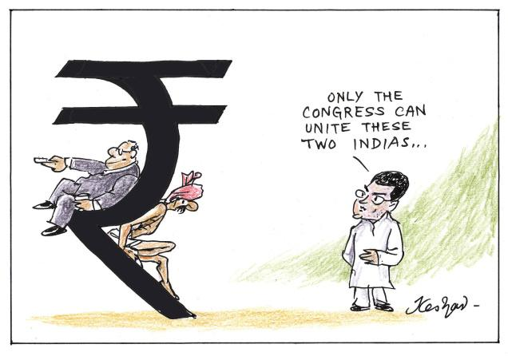
courtesy : The Hindu

05/11/10

04/11/10
1. CHARGING OF ENHANCED RATE OF LICENCE FEE IN CASE OF OUT OF TURN ALLOTMENT.
2. An employee becomes eligible for gratuity on the termination of his employment after he has rendered continuous service for not less than five years, according to Section 4(1) of the Payment of Gratuity Act, 1972.
Click here to see the details.

03/11/10
SOME INFORMATIONS
1) PRESENTATION ON TECHNOLOGICAL DEVELOPMENT:Presentation will be made shortly not like earlier meeting . The Venue will be intimated after the second week of NOVEMBER
2)OSA: The Department is going to seek the approval of the Finance Ministry.
3) CLOSURE OF NATIONAL SPEED POST CENTRE: our Federation has sent a protest letter to the Member (O).
4)CADRE RESTRUCTURING COMMITTEE: The meeting will be convened by DDG (est) in the third week of NOV 2010.
5) RECRUITMENT OF MSE: Notification will be issued shortly.
6) REVISION OF WAGES OF PART TTME AND CASUAL LABOURERS: Some Head of circles have not sent details despite repeated reminders from the DG Post. The D.O letter will be sent to the Heads of Circles who have not submitted details to the Directorate. After receipt of details the Department will take necessary action, for getting formal approval from DOPT.
7) EXTENSION OF ADHOC ARRANGEMENT IN HSG I: The DDG (p) informed that the Deportment has already taken up the issue with the DOPT for further extension.
8) POSTAL CIVIL UNION: National union of Postal civil wing Nongazetted Employees All India Conference will be held in patna or Kerala or Tamilnadu . Exact venue will be intimated within 15 days.
9) DRIVERS RECRUITMENT: The Finance Ministry has approved for Recruitment of Drivers in MMS . Necessary Departmental orders will be issued by the postal Directorate soon.
10) CHARGE HAND: Anomaly committee of the Postal Department had recommended Rs 4200 as grade pay for charge hand It has been sent for Finance Ministry for approval . The Ministry of Financé has returned the file raising some query. Let us hope that our Department will send positive note on this.
02/11/10
Expected DA increase from January 2011 is not less than 6%.
The All India Consumer Price Index number for (Industrial Workers) (Base 2001=100) for the month of Sep 2010 is 179 as announced by Statistics Department, Labour, Government of India. Based on this index, expected increase from January 2011 is not less than 6%.

