31/10/2011
Martyrdom Day, 31 October .
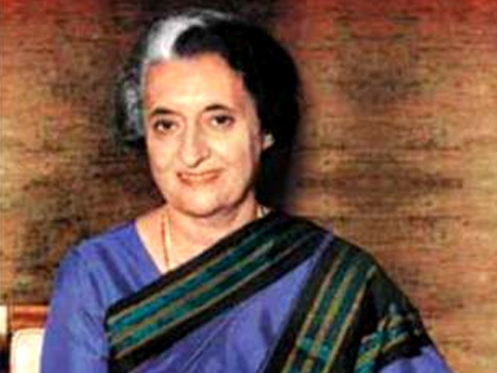
Symbol of India"s Indomitable Spirit
30/10/2011
FIRST REPORT OF GROUP OF MINISTERS TO CONSIDER MEASURES THAT CAN BE TAKEN BY THE GOVERNMENT TO TACKLE CORRUPTION.
click here to see the report
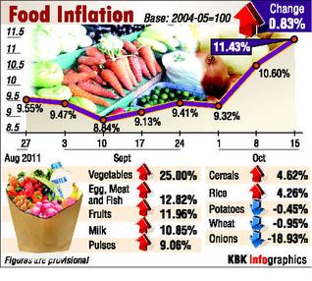
click here to see the details
27/10/2011
JCA DEMAND DIRECTORATE CONSIDERED AND INSTRUCTION ISSUED TO HEADS OF CIRCLES.
OUR CIRCLE SECRETARIES ARE REQUESTED TO TAKE UP THE ISSUE WITH CPMG CONCERN.

Subject:- Administrative Control over Speed Post Centres/Sorting Hubs.
D.G.Posts No. 6-5/2011-D Dated 20-10-2011
The matter relating to the administrative control over Speed Post Centres/Sorting Hubs falling under existing Postal or RMS division was raised by the staff side and was under consideration of this Directorate.
It has been decided that the issues of administrative control over Speed Post Centres/Sorting hubs in terms of placing under the administrative jurisdiction of Senior Superintendent/Superintendent of a Postal or RMS Division of a Postal or RMS Division maybe decided by the CPMG concerned taking into account local needs, administrative convenience and effective monitoring.
26/10/2011
Canadian postal workers
victory over govt interferencein bargaining.
click here to see the details.
25/10/2011
﻿﻿DIWALI GREETINGS TO ALL OUR VIEWERS

24/10/2011
Reservation in promotion Treatment of SC\ST Candidates promoted on their own merit
Click here to see the OM
23/10/2011
K.R. Birth centenary celebrations –
K.R. Birth centenary was celebrated in a grand manner at New Delhi in Subaham Auditorium on 22.10.2011.
Chw. Veeradendra Singh , M.P., and General Secretary AIC, inaugurated the celebration . Felicitation was addressed by S/Shri O.P. Gupta , Former S.G., N FPTE, G.K. Padmanabahan, EX. S.G. , FNPO, K.Vallinayagam , G.S. FNTO, A.H. Sidique G.S. , NUR-IV, O.P. Kanna, G.S., AIPAOA , D.Theagarajan, S.G., FNPO and others.
The program me was well organized by Delhi Circle coordinating committee, Our special thanks to Shri Devendra Kumar , Circle Secretary –RIII, Delhi.﻿
Commuted Leave to a Government Servant who has opted out of CGHS facilities and is availing the medical facility provided by the employer of his / her spouse - ﻿
click here to see the clarification.
21/10/2011﻿
MNOP COMMITTEE MEETING﻿
The fourth sitting of the MNOP Committee meeting held today at 3 P.M under the chairmanship of Mrs Manjula Prasher , Member(Operations). Com. M.Krishnan secratary General, NFPE and shri D.Theagarajan Secratary General FNPO attended.
The staffside categorically made it clear that they are totally against implementation of First Class mails hub (L1,L2) as it will adversely affect the efficiency of the mails sector and will lead to large scale closure /merger of offices in addition to dislocation of staff.The official argued that the MNOP is for the best interest of department and employees.
As no consensus could be arrived the meeting ended in disagreement.
D.Theagarajan M.Krishnan﻿
Secretary General Secretary General﻿
FNPO NFPE﻿ ﻿﻿

19/10/2011
GRAMIN DAK SEVAKS (GDS) DA ORDERS ISSUED
No.14-01/2011-PAP
Government of India
Ministry of Communications & IT
(Establishment Division)
Dak Bhawan, New Delhi-110001
Dated 18th October, 2011
To
All Chief Postmaster General
All GMs (PAF) Director of Accounts (Postal)
Subject: Payment of Dearness Allowance to Gramin Dak Sevaks (GDS) at revised rates w.e.f. 01.07.2011 onwards-reg.
Consequent upon grant of another installment of Dearness allowance , with effect from 1st July, 2011 to the Central Government Employees vide Government of India , Ministry of Finance , Department of Expenditure, OM No. 1(14)/2011-E-II(B) dated 3rd October,2011, the Gramin Dak Sevaks(GSD) have also become entitled to the payment of dearness allowance on basic TRCA at the revised rate with effect from 01.07.2011. It has, therefore, been decided that the dearness allowance payable to the Gramin Dak Sevaks shall be enhances from the existing rate 51% to 58% on the basic Time Related Continuity Allowance with effect from the 1st July, 2011.
2. The additional installment of dearness allowance payable under this order, shall be paid in cash to all Gramin Dak Sevaks. The payment of arrears of dearness allowance for the months of July to September, 2011, shall not be made before the date of disbursement of TRCA for the month of September, 2011.
3. The expenditure on this account shall be debited to the Head" Salaries" the relevant head of account and should be met from the sanctioned grant.
4. This issues with the concurrence of Integrated Wing vide their Dairy No. 123/FA/II/CS dated 18th October, 2011.
Sd/-
(Kalpana Rajsinghot)
Director (Estt.)
Tele o11-23096036﻿

18/10/2011
Postal industry sees innovation as machines that cut out jobs!
click here to see the details.
﻿CUPW files court challenge click here to see the details.
17/10/2011
OSA CLICK HERE TO SEE THE-CLARIFICATION
Attestation of Annexure-II (Affidavit) and Annexure-III (Disclaimer on Affidavit) in case of deceased claim case preferred where there is no nomination-
click here to see the clarification
DAK SEVA AWARDS GIVEN
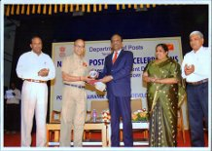
The Dek seva Award ceremony of India posts Tamil nadu Circle was held in a grand fashion recently .
Sri.R.Ramesh Our Ex Divisional secretary of the Chennai APSO was presented the award by Vice Chancellor COL.G Thiruvasagam on the occcassion.
MS Shanthi Nair, CPMG TN Circle K.Ramachandran PMG (M.M) MS Ramanujan PMG( CCR) were among those diginitaries who were present on the occasion.
Deutsche Post and Ver.di reach major
labour deal for 130,000 staff ﻿
﻿﻿
﻿

The deputy chairwoman of the Verdi Union, Andrea Kocsis, welcomed the agreement: “We have signed a Generation Pact that will allow our colleagues to reach the retirement age healthy while Deutsche Post and the German postal union Ver.di have reached a new “Generations Pact” for age-based working under the new condition of retiring at the age of 67, with a job guarantee until 2015 in exchange for lower starting wages.
The new collective bargaining agreement reached during the ninth negotiating round for the company’s 130,000 employees safeguards jobs extending dismissal protection until the end of 2015.
However, the deal reduces the entry wages for new employees by 4% on average. For example, a newly hired postman will earn €10.70 an hour compared to the current €11.13.
"The agreement is an important contribution to stabilising earnings in the Mail Division at €1 billion over the long term. It creates the leeway that the company needs to respond to future trends in a shrinking postal market," said Deutsche Post DHL CEO Frank Appel. "As a result, we are strengthening our competitive position and securing jobs."
The Generations Pact allows older employees to work actively until they reach the legal retirement age of 67, thus “preserving their knowledge and experience for the business”. At the same time, the deal creates employment opportunities for young people. More than 1,000 qualified trainees will thus be taken over next year while at least 1,500 part-time employees will receive a permanent contract at the end of 2011.
The legal partial retirement system will be complemented by the so-called "working-time accounts" and a "demographic fund". The working time accounts enable employees to build up a balance of time during their active professional lives which they can use for non-working periods or to work less when they get older.
In addition, Deutsche Post is setting up a so-called demographic fund for the first time to use the contribution from this fund for increasing payments to employees during the partial retirement. The fund is financed through the appropriate deduction of future wage increases.
Walter Scheurle, Member of the Management Board responsible for personnel at Deutsche Post DHL, commented: “With the introduction of working-time accounts and the demographic fund, the negotiating parties have added a new tool to the current system of bargaining agreements. It offers attractive models to older employees that will allow them to stay at the company until they retire by working fewer hours.”
With effect from 1 January 2012, the union and Deutsche Post also agreed on new vacation policies based on the German General Equal-Treatment Act which now depend on job tenure and not the age.
While the 990 parcel delivery districts will continue to be operated by the subcontracted service partners, the company will extend its outsourcing activities in transportation reducing the number of its own drivers from the current 3,600 to 2,600. As for mail delivery, no mail districts will be operated by subcontractors. All regulations applying to subcontractors will remain in effect through December 31, 2015.
opening up new opportunities for young employees.”
She acknowledged that the top-up payment due during the partial retirement has a social component as employees with a lower income will get a higher top-up payment as the ones with a better salary. “We want the workers who work physically hard but are not well paid to take part in this model,” Koscis stressed﻿.
16/10/2011
Postal workers demonstrate against Postal liberalisation
in Europe﻿.
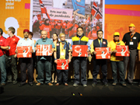 | ber 2011
﻿
Post workers in their uniforms from a cross Europe opened the afternoon session of the UNI Europa Conference in Toulouse. With a march through the conference room, they called the attention of the delegates to the dramatic situation in the European postal sector. The European Union completed liberalisation of the postal market in all Member States on the 1st of January 2011. The consequences are lower quality postal services, higher prices and social dumping created by competition based on salaries and wages.
Ingeborg Saetre, president of UNI Europa Post&Logistics presented the success of the Norwegian postal union, which used information on the EU situation and the support of the European postal trade unions and UNI Europa Post & Logistics to stop postal liberalisation in Norway. The Norwegian parliament listened finally to postal union Postkom's arguments and decided not to implement the Directive as they are not member of the European Union.
Despite this great success, post liberalisation continues unabated in the Member States of the EU. The postal trade unions are fighting together with UNI Europa Post & Logistics against the negative consequences of postal liberalisation and demanding to regulate deregulation and create quality jobs for quality services. ﻿
14/10/2011
CLOSING OF CENTRAL GOVERNMENT IN CONNECTION WITH ELECTIONS TO LOK SABHA/STATE ASSEMBLY /PANCHAYAT /MUNICIPALITIES/CORPORATION OR OTHER LOCAL BODIES -
DOPT CLARIFICATORY ORDERS ISSUED
{CLICK HERE FOR DETAILS}
﻿
Postal strike has begun in Italy.
A postal strike has begun in Italy due to the non-payment of productivity bonuses in 2010 and their non-renewal for 2011-2013. Workers are also protesting the lack of staff in post offices and delivery centres. One hundred forty thousand employees are affected. The mobilization, which will take place October 3-30, was organized by SLP CISL, Uilposte, Confasal UGL, Com Com after the unsuccessful conclusion of their negotiations for the renewal and signing of a collective agreement.
"We are drawing the attention of the entire leadership,” says Mario Petitto, General Secretary of CISL SLP. “There is a strange silence and a strange apathy that threatens to undermine the foundations of the largest service provider in the country. For this we will take to the streets not for political reasons, but to assert a strong role in our company."
Petitto notes that "workers are not compensated for the sacrifices that have allowed the company to achieve the outstanding business results they have seen, however, the management is handsomely compensated."
SLP CISL has pointed out that no consensus has been reached with the company and only the CGIL has signed an agreement.
The union has also pointed out that the company’s marketing makes it appear as if the postal service is strong, efficient and oriented toward international markets while inside the company is rotting in terms of quality of service and volume and revenue drops that will have a huge impact on employment.
"Surely we will create some inconvenience to the citizens,” said Petitto. “But it is absolutely necessary to tackle and resolve the problems."
﻿PPF INTEREST RATE ENHANCED
click here to see the Times of India News
INDIA POST REJECTS BIDS OF HCL COMENT WIPRO DIMENSTIO N DATA AND UTL FOR CISCO"S IT UPGRADATION EQUIPMENT
Click her to see the Economic times news
13/10/2011﻿
NATIONAL FEDERATION OF POSTAL EMPLOYEES
1st Floor, North Avenue Post office, New Delhi – 110001
FEDERATION OF NATIONAL POSTAL ORGANISATIONS
T-24, Atul Grove Road, New Delhi – 110001
Ref: No. MNOP/GENL/2011 Dated – 11.10.2011
To,
Mrs. Manjula Parashar
Member (Operations)
Postal Service Board
Dak Bhawan, New Delhi – 110001
Madam,
Sub: - MNOP Committee Meeting
Kindly recall the discussion we had with you in the MNOP Committee meeting held on 10.10.2011
As already pointed out by us the minutes of the last meeting do not correctly reflect the view points expressed by the staff side representatives. We have neither agreed with the concept of new sorting hubs for speed post operations nor appreciated the concept for network redesign for first class mails. Our request for change of administrative control of all speed post hubs to RMS Superintendents and also our apprehension regarding closure/merger of sorting offices, especially in the metro/big cities in the wake of implementation of L1, L2 concept was also not included in the minutes. We are rather disappointed to note that inspite of our repeated request the Mckinsey consultancy’s full recommendations are not made available to us.
Regarding the discussion held on 10.10.2011, we had examined in detail all the pros and cons of the suggestions and assurances given by the administration in the meeting. We did not find any reason to change the stand taken by us as regards to implementation of first class mails hub i.e., L1 & L2. We have unanimously decided to oppose the implementation of the L1, L2 on the following counts.
1. It will definitely cause delay to the public mails as compared to the position prevailing now. We are not against improving the quality of the mail operations but it should not be at the cost of efficiency of the Postal Services.
2. Whatever may be the assurances given by the administration, the implementation of L1, L2 concept will result in closure/merger of sorting offices and divisions in the metros in the near future and at other stations at later date.
3. There will be large scale dislocation of staff and their carrier prospects will be adversely affected.
4. We further strongly feel that the international experience in the postal sector, after implementation of such recommendations, have proved disastrous and we don’t want that to happen in India Post by implementing the Mail Network Optimisation Project recommended by Mckinsey.
Finally we once against request you to desist from implementing the MNOP for first class mails i.e. L1, L2
Yours faithfully,
Sd/- Sd/-﻿ M.Krishnan D.Theagarajan﻿﻿
Secretary General,NFPE Secretary General,FNPO﻿

﻿12/10/2011
Cadre Restructuring Meeting Outcome
1)Staff side has submitted a proposal
Official side informed that they will study staff side proposal and they will revert back with their strategy.
2)Official side has agreed to recomend to the Secratary (P) for constituiting a seperate committe for MMS .﻿
11/10/2011﻿﻿
Proposal Submitted by FNPO in regard to additional Hubs﻿
Click here to see the details
10/10/2011﻿
SG FNPO PROGRAME.
10/10/2011 to 15/10/2011- NEW DELHI ﻿
08/10/2011
NEW RTI INFORMATION ABOUT MNOP .
Pilot project of speed post restructuring/First class mail restructuring was not placed in the Postal Board.
﻿﻿Market share of speed /First class Mails not available.
APPEAL AGAINST THE RTI INFORMATION GIVEN BY DIRECTOR MAIL MANAGEMENT
Click here to see the details
Join to save America's Postal Service
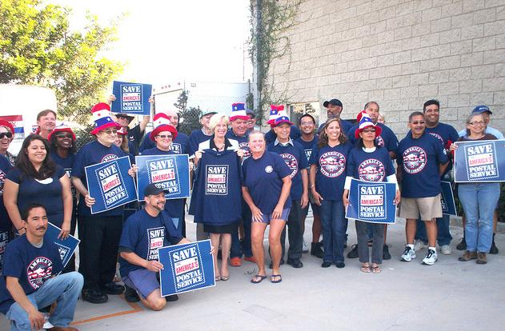
On Tuesday 27 September, members of the US Postal Service's four workers unions will join forces with members of their communities to send a message to the US nation and Congress
Save America's Postal Service: On Tuesday 27 September, members of the US Postal Service's four workers unions will join forces with members of their communities to send a message to the US nation and Congress through rallies at the home office of each member of the US Congress, to thank those members who have signed on as co-sponsors of H.R. 1351, and to encourage those who have not signed on as co-sponsors to do so. Click here to visit the event's official website, which includes a continuously updated list of rally sites—(currently standing at 531 and rising!) and more information on the rallies
Save Americas Postal Service

07/10/2011
SENIOR POSTMASTER EXAMINATION.
CLICK HERE TO SEE THE SCHEDULE
06/10/2011
International Trade Unions very critical on core labour rights in India
click here to see the details
05/10/2011
It is regretted to inform that our beloved circle secretary of Bihar circle Shri Yadunandansingh has passed away today at 9.15.am . The service rendered by Shr yadubabu is unforgettable during his tenure he build of NUR-C NO-1 position in Bihar circle. NUR-C conveys deep condolence to his family members .May his soul rest in peace.
04/10/2011
MEETING ON MNOP HELD ON 29/09/2011 With General secretaries of R-3 and R-4.﻿


S/SRI M. Krishnan Secretary General NFPE and. D. Theagarajan Secretary General FNPO explained the gist of discussion held in the MNOP committee held on 27.09.2011.
After detailed discussions the following decisions are taken.
1. Regarding the already implemented Speed Post Hubs the following modifications may be sought for positive decision.
(a) More intra circle hubs should be opened to reduce back routing and delay. Circle Secretaries of R-3 and R-4 Unions (NFPE&FNPO) should give concrete proposals regarding additional hubs required and also for change of jurisdiction from Postal Side to RMS .Report from Circles Secretaries should reach the General Secretaries /Secretary Generals before 5.10.2011.
2. Regarding first class mails hub (L1,L2) the meeting came to the unanimous conclusion that if the L-1,L-2 is implemented the following will be position:
(a) Most of the L-2 office will face closure in the near future due to fall in mail volume.
(b) In major metros/cities all the existing sorting offices and Divisions will be merged and closed.
(c) There will be large scale transfer and displacement of staff affecting their career prospective at large. Large number of Mailman staff and GDS may become surplus in metro/cities.
(d) L-1,L-2 will result in unnecesary back routing and avoidable delay in transmission/delivery of mails.
In view of the above the meeting decided to oppose implementation of L-1 and L-2 .
It is also decided to prepare for another industrial action if the department go ahead with implementation of L-1, L-2 inspite of our opposition. It is decided to approach the Hon`ble Minister for Communications & IT through MPs and appraise him, of the gravity of the situation and request intervention.
In the meantime the Secretary Generals shall prepare a detailed note explaining the above impact of L-1, L-2 for educating the rank and file membership.
Grant of special allowance for child care for women with disability.
click here to see the clarification
Department of Post issued DA orders.
click here to see the order.

03/10/2011
DA ORDERS ISSUED BY MOF
click her to see the order
02/10/2011
International Day of Non -Violence
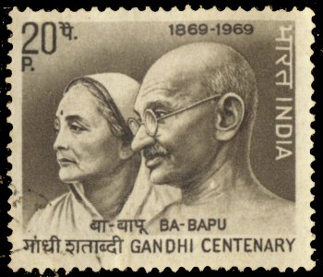

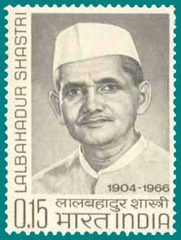
" We can win respect in the world only if we are strong internally and can banish poverty and un-employment from our country"
-Lal Bahadur Shastri
﻿30/09/2011
MINUTES OF THE MEETING OF THE COMMITTEE CONSTITUTED TO LOOK INTO ISSUES RELATING TO MAIL NETWORK OPTIMIZATION PROJECT
In accordance with the instructions issued vide Directorate memo No.08/9/2011-SR dated 12.7.11, the Committee constituted to look into issues relating to Mail Network Optimization Project met on 27.09.11. The meeting was attended by the following:
(i) Ms. Manjula Prasher, Member (Operations)
(ii) Ms. Shanthi S. Nair, CPMG, TN Circle
(iii) Shri Rishikesh, Director (Mail Management)
(iv) Shri M. Krishnan, Secretary General
(NFPE)
(v) Shri D. Theagarajan, Secretary General (FNPO)

2. The terms of reference of the Committee were as follows:-
"The Committee will review the mail arrangement made as sequel to creation of Speed Post Hubs which, as represented by Staff Side, are causing delay as compared to the position prevailing earlier. The committee will also review the formation of L-1 and L-II in regard to First Class Mail".
3. Member (Operations) apprised the representatives of the staff side on the initiatives taken as part of Mail Network Optimization Project to improve the quality of Speed Post operations. She also stated that improvement in quality of mail related services was the key objective of the project, and hence, the staff side should fully cooperate with the administration in this endeavour. She further informed that cases relating to delay and back-routing of mail in certain areas have been reviewed and necessary action is being taken. For this purpose, mail arrangements have already been revised in case of HP, Haryana, Punjab, UP, Uttarakhand and AP Circles. Cases relating to other Circles are also being examined.
4. It was informed that instances of delay and back-routing of mail relating to Speed Post operations brought to the notice by the staff side are being looked into and necessary action is being taken for revision in existing mail arrangements wherever necessary. The staff side was also requested to give concrete suggestions on any particular area where improvement is needed. These suggestions would be sent by the staff side within a week. The staff side also agreed with the concept of new sorting hubs for Speed Post operations and opined that at best, a few more intra-Circle Speed Post hubs might be required to strengthen the operational network.
5. The features of performance monitoring tool, such as Key Performance Indicators (KPIs) website and analysis of performance of the Circles through video conference were explained in detail to the staff side. The staff side appreciated the efforts made in this area.

6. Member (Operations) informed that implementation of the network redesign concept for First and Second Class mail was equally crucial. The proposed network redesign seeks to minimize fragmentation in the processing of mail across the existing network, streamline processes followed in the mail offices, provide new tools and equipments for use in mail offices and put in place a technology-enabled environment for mail operations.
7. The staff side demanded copies of the reports submitted by the Consultants on restructuring of Speed Post and First Class mail network. It was agreed that relevant sections of the reports pertaining to operational restructuring would be provided to the staff side.
8. The staff side agreed and appreciated the concept for network redesign for First Class mail. However, they expressed their apprehensions about transfers of the staff concerned in near future. They requested that an assurance may be given that the staff concerned will not be transferred for a specific period.
9. It was decided that the Committee would again meet on 10.10.11 to discuss issues relating to improvement in Speed Post operations based on the suggestions received from the staff side and the Heads of Circles, if any, and implementation of the network redesign concept for First and Second class mail.
The meeting ended with a vote of thanks to the Chair.

