15/02/2012
Eastern European Trade Unions strategize on postal liberalization
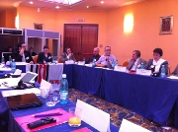
Representatives from nine trade unions in Eastern Europe who will have to liberalise their postal markets by 1 January, 2013 gathered in Bucharest (2-3 February 2012) to discuss postal liberalization.
Eastern European Trade Unions strategize on postal liberalization
Representatives from nine trade unions in Eastern Europe who will have to liberalise their postal markets by 1 January, 2013 gathered in Bucharest (2-3 February 2012) to discuss postal liberalization.
Speakers from trade unions in Western and Northern Europe where postal liberalization has already happened, such as Sweden, Belgium, Germany and the Netherlands, spoke about how liberalization affected postal workers' jobs and how unions can prepare their members for the upcoming changes and minimize the adverse effects.
Participants discussed adding social regulation to postal laws, organizing members in the new competitors and having strong collective agreements.
This seminar was part of the Trade Unions Preparing for Change project that was funded by the European Commission. Two more workshops will take place in Croatia and Belgium
14/02/2012
 | issue of Foreign Direct Investment
Watch the full interview with Philip Jennings on CNBC Click the below link
http://www.abndigital.com/page/multimedia/video/beyond-markets/1168561-Job-Creation-Strategies-For-Global-Economic-Recovery.
13/02/2012
South Africa and India should join hands to tackle global retail challenge Philip Jennings(General Secretary of UNI)
Click here to see the details
11/02/2012
IPO results will be declared by third week of February
Click the below link to see the details
- Release of Revised MNOP Script
- Restructuring of the existing operational network and processing arrangement for 1st class registered and unregistered mails
10/02/2012
JCM Departmental Council held on 10.02.2012. Ms. Manjula Prashar, Secretary, Department of Posts, presided. All Postal Board members and senior officers were present. All notified items were discussed. Minutes of the Standing Committee meeting held on 02.02.2012 and todays meeting will be published shortly. Strike charter of demands/items were not discussed again. It is assured that progress report on all the items discussed earlier will also be furnished to the staff side.
Click the below link to see the details
- STRIKE NOTICE SERVED
- Grant of Uniform and kit maintenance allowances
- Release the Pension/DCRG of employees against whom minor penalty proceedings concluded after retirement
- Committee of Officers to examine matter pertaining to Gramin Dak Sevaks
- Minutes of the Meeting of the Committee constitued under the Chairmanship of CGM, to consider the issues related to Postmen

09/02/2012
Click the below link to see the details
  - Implementation of Redesigned Network for First Class Mail
  - Special Recruitment Drive for Backlog Vacancies in SC and OBC Quota
08/02/2012
Click the below link to see the details
- Expecting Dopt order regarding the issue of Date of Next Increment
- Uploading clarification in respect of Logistics Post NIT on India Post Website
- CVC Disposed of 1272 cases in December 2011
06/02/2012
Bihar FNPO affiliates has decided to celeberate KR birth centunary today at Patna, SG FNPO will address the function. Details will be posted in Federal Sentinel
Click the below link to see the details
- CADRE REVIEW DOPT
- DOPT issued FAQ on FCS
- FAQ related to R&R and DC Division of DOPT
- Citizens Charter
03/02/2012
Click the below link to see the details
- Regulation of strike period
- JCM Departmental Council Meeting
- FAQ on LTC
02/02/2012
Click the below link to see the details
- Details of Round Table on National Postal Policy held on Feb 01 2012
- Dearness Allowance is likely to rise by 7% from Jan 2012
Programme of SG FNPO
FROM 02-02-2012 TO 12-02-2012 - DELHI.

01/02/2012
Round Table Meeting on National Postal Policy on Feb 1 2012
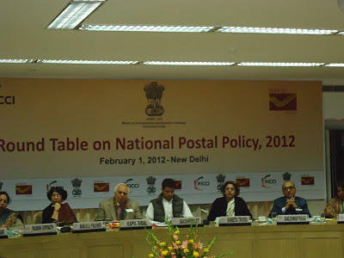
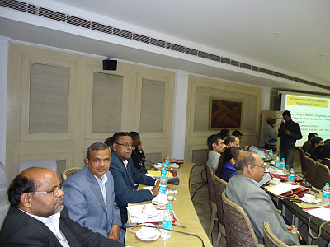
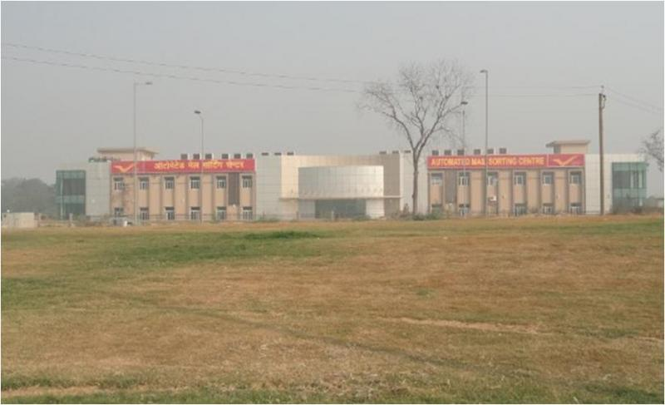
AMPC - A BOON OR BANE
Click here to see details

MoC has called for a meeting to discuss about the National Postal Policy on Feb 1 2012. Details will be published shortly.

﻿

27/02/2012
Trade unions reject PM's appeal to call off strike - courtesy The Hindu
Click here to see the details
26/02/2012.
First time since Independence trade unions, cutting across ideological and political affiliations, have joined hands to register their protest ............
In an unprecedented show of unity, all trade unions in the country have come together on the same platform and given a call for a general strike on February 28.
This is the first time since Independence that trade unions, cutting across ideological and political affiliations, have joined hands to register their protest on a wide range of issues arising out of the liberalisation policy.
The liberalisation and new economic policies unveiled since 1991 have undermined the interests of workers to such an extent that trade unions representing the Left, Right and Centrist parties have been forced to come together. Such unity was not witnessed even during or after Emergency, All India Trade Union Congress general secretary Gurudas Dasgupta told The Hindu.
Workers of all 11 recognised unions (to be recognised, a union has to have four lakh members) and 5,000 un-affiliated unions will strike work, affecting banking, postal, port and government operations.
The unions have come together on a five-point charter, which seeks strict enforcement of all basic labour laws without any exception or exemption and stringent punitive measures for violation; a universal social security cover for unorganised sector workers without any restriction and creation of a National Social Security Fund.
According to the convener of the coordinating committee of the unions and president of the Congress-affiliated INTUC, G. Sanjeeva Reddy, and CITU general secretary Tapan Sen, things have come to such a pass in some States that even registration of new trade unions is not being allowed.
The charter seeks stoppage of disinvestment in profit-making Central and State public sector units. Disinvestment is paving the way for privatisation of the PSUs, say the unions.
The trade unions want the government to step in against contractorisation of permanent/perennial work, and payment of wages and benefits to contract workers at the same rate as are available to regular workers. Other demands include amendment of the Minimum Wages Act to ensure universal coverage, irrespective of the schedules, and fixation of the statutory minimum wage at not less than Rs. 10,000, removal of all ceilings on payment of and eligibility for bonus, Provident Fund, increase in the quantum of gratuity and assured pension for all.
Mr. Gupta said that despite several representations in the last few months, the government was unmoved on the major concerns of the working people.
At the annual Indian Labour Conference on February 14 and 15, in the presence of Prime Minister Manmohan Singh, he articulated most of the demands and conveyed to him why workers were compelled to take recourse to a strike. However, there was no response from either Dr. Singh or the Labour Minister.
Keywords: trade unions,strike call,liberalisation policy
coutesy HINDU.
24/02/2012.
GENERAL STRIKE ON 28TH FEBRUARY 2012.
FEDERATION OF NATIONAL POSTAL ORGANISATIONS
T-24, Atul Grove Road, New Delhi - 110 001.
E-mail : theagarajannachi@hotmail.com
Circular No. 7/2012 Date : 22-2-2012
Dear Colleagues,
FWC Members / CHQ Office bearers / Circle Secretarires of FNPO affiliated Unions
GENERAL STRIKE ON 28TH FEB 2012
Everyone is aware that the Postal Federations have jointly given a call to all Postal employees to participate in the strike on 28th February 2012 (Tuesday) based on the call given by Central Trade Unions.
Now some of the colleagues raised a query as to why FNPO is participating in the forthcoming one day strike. This is not the first time that the FNPO called one day strike. Earlier in the year 2004, when Supreme Court gave judgment against the strike, we jointly gave a call for one day strike.
After a long gap of eight years, we have joined for one day strike seeing serious anti-labour policies of the Government.
Decision of Central Trade Unions
Central Trade Unions conducted a meeting at Delhi on 7th September 2011 and decided to go on strike for one day in protest against the anti-labour policies of the Government.
They also conducted state-level conventions. Dr. Sanjeeva Reddy, President, INTUC attended meeting at Hyderabad on 5th February 2012 and assured that all INTUC affiliated unions would participate in the strike on 28-2-2012 in joint convention where AITUC, CITU, BMS and others participated.
On January 2012, joint convention was organized by Central Trade Unions. Our INTUC Vice-President Sri Chandrasekar shared the dais with AITUC, CITU and BMS and called upon all INTUC workers to participate in the strike.
Sector-wise Strike preparation
The Telecom workers of FNTO, BSNLEU, NFTE and BTEF have decided to participated in the strike on 28-2-2012. They issued strike notice organizing the conventions state-wise to make the strike successful.
In Defence, INTUC, AIDEF and BMS have jointly give a strike notice against the policies of the Government.
In LIC, INTUC Union decided to participate in the strike on 28-2-2012.
Our JCM leader Sri M. Raghaviah, called upon all the NFIR members to hold Dharna and conventions explaining the anti labour policies of the Central Government in favour of strike on 28th February 2012.
Taking all the above the FNPO has decided to participate in the strike on 28th February 2012 with all other Central Government employees unions.
The demands putforth by the Central Trade Unions to the Government are very important and the success of the strike alone will decide the Central Government employees future.
WORLD WIDE POSTL STRIKE.
FNPO colleagues and viewers of FNPO web site are very well aware what is going on in the Postal Department world-wide. In the last two months, Postal strikes were organized in USA., UK, France, Kenya, Belgium. Further FNPO colleagues are aware that Asia pacific Region Postal Sectors are either corporatized or privatized except India, Bangaladesh and Nepal.
In India, the top bureaucrats are of the firm opinion that there is no need to give subsidies to the Postal Department. If Government takes such decision, our position would be very awkward and dangers to every Postal employees.
Present setback in Postal Service in African Region, American Region, European Region and Asia Region may come to India post at any time. If we want to resist, we have to unite and fight. At this juncture we have no other alternative except to participate in the strike to draw the attention of the Government.
I hope and trust that all our Circle Secretaries, Divisional Secretaries and CHQ office-bearersand our members of all our affiliated unions of FNPO will make this one day strike a resounding success in India post. Anticipating your fullest co-operation.
Yours Fraternally,
D.Theagarajan.
23/02/2012
Click the below links to see the details
- Minimum Wages Act Coverage for all Employments
- Clarification regarding regulation of payment of employer
- Children Education Allowance
- Children Education Allowance CLARIFICATION
22/02/2012
MEMORANDUM SUBMITTED TO SECRETARY, DEPARTMENT OF POST, NEW DELHI,ON THE PROBLEMS OF CASUAL,PART TIME, CONTINGENT & CONTRACT WORKERS IN THE DEPARTMENT FOR CONSIDERATION AND SETTLEMENT.
Click her to see the memorandum.
20/02/2012
TWO MILLION Spanish workers take to street to fight new labour law, demand justice .
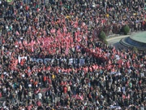CLICK HERE TO SEE THE NEWS.
19/02/2012
Health tips on a postcard - courtesy The Hindu
Click here to see the details
18/02/2012
Draft minutes of the meeting of Departmental Council (JCM) held on 10.02.2012
click her to see the details
17/02/2012

Women postal workers in Morocco to strike on 8 March
Click here to see the details

\
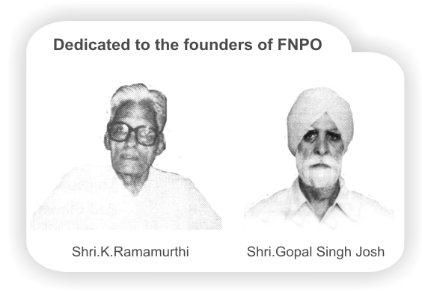

15/02/2012
Eastern European Trade Unions strategize on postal liberalization
Representatives from nine trade unions in Eastern Europe who will have to liberalise their postal markets by 1 January, 2013 gathered in Bucharest (2-3 February 2012) to discuss postal liberalization.
Eastern European Trade Unions strategize on postal liberalization
Representatives from nine trade unions in Eastern Europe who will have to liberalise their postal markets by 1 January, 2013 gathered in Bucharest (2-3 February 2012) to discuss postal liberalization.
Speakers from trade unions in Western and Northern Europe where postal liberalization has already happened, such as Sweden, Belgium, Germany and the Netherlands, spoke about how liberalization affected postal workers' jobs and how unions can prepare their members for the upcoming changes and minimize the adverse effects.
Participants discussed adding social regulation to postal laws, organizing members in the new competitors and having strong collective agreements.
This seminar was part of the Trade Unions Preparing for Change project that was funded by the European Commission. Two more workshops will take place in Croatia and Belgium
14/02/2012
issue of Foreign Direct Investment
Watch the full interview with Philip Jennings on CNBC Click the below link
http://www.abndigital.com/page/multimedia/video/beyond-markets/1168561-Job-Creation-Strategies-For-Global-Economic-Recovery.
13/02/2012
South Africa and India should join hands to tackle global retail challenge Philip Jennings(General Secretary of UNI)
Click here to see the details
11/02/2012
IPO results will be declared by third week of February
Click the below link to see the details
- Release of Revised MNOP Script
- Restructuring of the existing operational network and processing arrangement for 1st class registered and unregistered mails
10/02/2012
JCM Departmental Council held on 10.02.2012. Ms. Manjula Prashar, Secretary, Department of Posts, presided. All Postal Board members and senior officers were present. All notified items were discussed. Minutes of the Standing Committee meeting held on 02.02.2012 and todays meeting will be published shortly. Strike charter of demands/items were not discussed again. It is assured that progress report on all the items discussed earlier will also be furnished to the staff side.
Click the below link to see the details
- STRIKE NOTICE SERVED
- Grant of Uniform and kit maintenance allowances
- Release the Pension/DCRG of employees against whom minor penalty proceedings concluded after retirement
- Committee of Officers to examine matter pertaining to Gramin Dak Sevaks
- Minutes of the Meeting of the Committee constitued under the Chairmanship of CGM, to consider the issues related to Postmen

09/02/2012
Click the below link to see the details
  - Implementation of Redesigned Network for First Class Mail
  - Special Recruitment Drive for Backlog Vacancies in SC and OBC Quota
08/02/2012
Click the below link to see the details
- Expecting Dopt order regarding the issue of Date of Next Increment
- Uploading clarification in respect of Logistics Post NIT on India Post Website
- CVC Disposed of 1272 cases in December 2011
06/02/2012
Bihar FNPO affiliates has decided to celeberate KR birth centunary today at Patna, SG FNPO will address the function. Details will be posted in Federal Sentinel
Click the below link to see the details
- CADRE REVIEW DOPT
- DOPT issued FAQ on FCS
- FAQ related to R&R and DC Division of DOPT
- Citizens Charter
03/02/2012
Click the below link to see the details
- Regulation of strike period
- JCM Departmental Council Meeting
- FAQ on LTC
02/02/2012
Click the below link to see the details
- Details of Round Table on National Postal Policy held on Feb 01 2012
- Dearness Allowance is likely to rise by 7% from Jan 2012
Programme of SG FNPO
FROM 02-02-2012 TO 12-02-2012 - DELHI.

01/02/2012
Round Table Meeting on National Postal Policy on Feb 1 2012
AMPC - A BOON OR BANE
Click here to see details

MoC has called for a meeting to discuss about the National Postal Policy on Feb 1 2012. Details will be published shortly.

﻿

﻿

