31/01/2012﻿﻿﻿﻿
Click the below links to see the details
- Postal NEWS around the world
- Approval for funding Phase-Ill of the UIDAI
- ﻿Postal Dept works towards Bank Permit﻿
- Madurai Kamaraj University (MKU) to tie up with India Post, 2012﻿
- EPFO may fix minimum pension at Rs 1,000﻿
- 5 Things You Never Knew Your Cell Phone﻿
29/01/2012﻿﻿﻿
Number of qualified LGO (PA/SA) circle wise
Click here to see the details
28/01/2012﻿﻿
Click the below links to see the details
- Directorate of Estates takes various initiatives to streamline government accommodation
- Check-list for APAR of CSS Officers
- NPS fees to be charged based on quantum of Contribution
- Release of Revised MNOP Script & Major Penalty Proceedings Recommended against 81 Officers
- Pre‐Bid Meeting on RFP for Long Term Strategy for Life Insurance Business of
Department of Posts held on 28/11/2011: Queries, Suggestions and Responses
- Addendum to RFP for Long Term Strategy for Life Insurance Business of
Department of Posts
- Maximum Sum Assured for PLI and RPLI are Revised ﻿
27/01/2012﻿
'End of an era for Post Office', says CWU﻿
Click here to see the details

26/01/2012
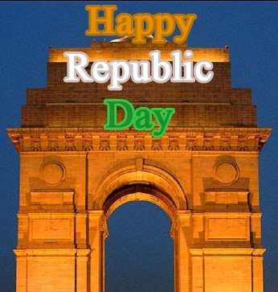
25/01/2012

Recommendations of 6th Central Pay Commission - Applicability of revised Group 'D’ pay scales to Casual Labourers with Temporary Status ﻿

Click here to see the details﻿
Click the below links to see the details
- CONSTITUTION OF COMMITTEE FOR ORGANIZATIONAL RESTRUCTURING IN DEPARTMENT OF POSTS﻿
- Department of Posts (Multi Tasking Staff) Recruitment Rules, 201 - speeding up of recruitment process﻿
- Minutes of the meeting of the Committee constituted under chairmanship of CGM, PLI to consider issues related to Postmen﻿

Today the President and SG FNPO met CGM(PLI) along with PRESDIENT FNPO DPLI KOLKATTA and SANJOY ROY Circle Secretary , and discussed the following issues :-
1. Testing of newly developed PLI software in O/o DPLI, Kolkata –CGM PLI agreed our views.
2. Training for all the officials of O/o DPLI, Kolkata by NIC—CGM PLI assured to look in to the matter.
3. Existing staff should not be transferred—redeployed in productive work in O/o DPLI Kolkata—This is agreed by CGM PLI.
24/01/2012
LGO results has been dispatched by Directorate today ( 24.01.2012)to all the circles.
Circle Secretaries are requested to take up the issue with respective Circle Chief PMG to publish the results as early as possible.﻿
Enhancement of Various Allowances by 25% from 01.01.2011﻿
Click here to see the details
Important Meetings in Directorate
1. Postmen Committee Meeting - 25.01.2012
Chairman --- CGM (PLI)
2.Standing Committee Meeting to discuss pending items of Departmental Council subjects --- 02.02.2012
Chairperson ---Member (P)
3.Departmental Council ﻿ Meeting to discuss New Subjects ----10.02.2012 ﻿
Chairperson --- Secretary, DOP ﻿

23/01/2012﻿
LGO Results will be declared today evening by the Circles.
Qualified List has been sent to Circles today by the Directorate.
Total no of Vacancies in P.A | 1688
Total no of L.G.O qualified as PA | 1220
Total no of Vacancies in SA | 398
Total no of L.G.O qualified as SA | 51
﻿Names of the qualified officials Circle wise will be published in our web shortly.
﻿22/01/2012
Postal Policy: Draft Agenda for Roundtable﻿
Click here for details
21/01/2012
Programme of SG FNPO
FROM 20-01-2012 TO 25-01-2012- DELHI.
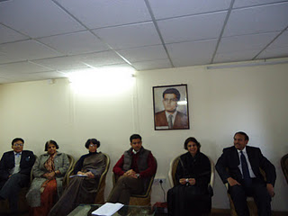

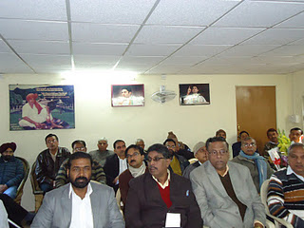﻿
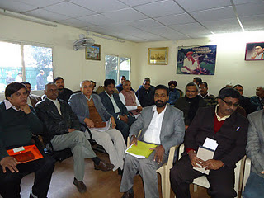
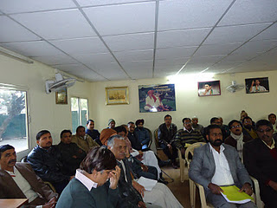
﻿MEETING WITH MINISTER
Meeting with Sri. Sachin Pilot, Hon’ble Minister of State of Communications, was held today (21.01.2012) at 11.00 AM. Meeting lasted for 30 minutes. The staff side presented a memorandum to the Minister, containing the issues which needs Minister’s intervention. Minister agreed to examine each case on its merits and take early decision. The following issues were discussed with the Minister, in detail.
(i) Issues relating to Gramin Dak Sevaks
(ii) Issues relating to casual, Part-time, Contingent employees
(iii) Revision of overtime allowance
Regarding GDS issues like status, promotion etc. Minister assured to examine the cases in detail and taken a decision at the earliest. Regarding reduction of existing allowances of GDS, the Minister gave on the spot instructions to the Secretary, Department of Posts, to issue orders protecting the existing TRCA in full. Further regarding cash handling point Minister directed Secretary that it should be finalized before 31st January 2012. He assured that the other issues like Bonus ceiling, providing norms for left out items etc. will also be given sympathetic consideration. Regarding casual labourers issues Minister gave direction to the Postal Board to expedite the orders. Minister further assured that he will definitely call for the files relating to the other items mentioned in the memorandum and an indepth examination of the issues will be made and decision taken early.
The staff side thanked the Minister for giving us an opportunity to present our cases in front of him. The staff side was represented by Sri. D. Theagarajan (S/G, FNPO), Com. M. Krishnan (S/G, NFPE),﻿Com. K. V. Sridharan, (G/S, P3, NFPE), Sri﻿. L. D. Kaushik (P3, FNPO), Com. Ishwar Singh Dabas (G/S P4, NFPE) Sri﻿. Ashok Sharma (P4, FNPO), Com. Giriraj Singh (G/S, R3, NFPE), Sri﻿. Devendra Kumar, Sri﻿. Pawan Kumar (R3, FNPO), Com. P. Suresh (G/S, R4 NFPE), Sri﻿. Satish Chander (R4, FNPO), Com. Pranab Bhattacharjee (G/S, Admn. NFPE), Com. S. B. Yadav (AIPAEA), Sri﻿. O. P. Khanna (G/S AIPAOA), Com. S. S. Mahadevaiah (G/S AIPEDEU), Sri﻿. Gautam Das (Org. Secy., NUGDS), Com. R. N. Parashar (ASG, NFPE).﻿
Click here to see the memorandum﻿

20/01/2012﻿﻿
Click the below links to see the details
Orders on Strike Demand - 9 ﻿
Orders on Strike Demand - 10
19/01/2012﻿
ALL INDIA STRIKE ON 28/02/2012﻿
Click here to see the details
Grant of Travelling & Daily Allowance to mail overseers in place of Night halt allowance
Click here to see the order
17/01/2012
Today SG FNPO and President met Member ( O) and Member (P) and discussed various issues. Details will be published in Federal Sentinel
Minutes of the meeting taken by Secretary(Posts)/Postal Services Board with the Postal Joint Council of Action on 10.01.2012 and 12.01.2012 in Dak Bhawan﻿
Click here to see the details
15/01/2012

14/01/2012﻿
FNPO ﻿* NFPE * AIPEDEU * NUGDS

ALL INDIA STRIKE ON 28.02.2012

JOINT CALL OF ALL CENTRAL TRADE UNIONS & FEDERATIONS

INTUC, BMS, AITUC, CITU, HMS, AIUTUC, AICCTU, UTUC, TUCC, LPF, SEWA

AGAINST THE ANTI WORKING CLASS POLICIES OF THE GOVERNMENT
﻿ POSTAL JOINT COUNCIL OF ACTION
FNPO ﻿* NFPE * AIPEDEU * NUGDS
UNANIMOUSLY DECIDED TO JOIN THE
HISTORIC STRIKE ON 28.02.2012
The attack on Postal and RMS Employees including Gramin Dak Sevaks is mainly due to the policy of the Government against which all the Central Trade unions and Federations are jointly fighting. We as Postal workers, it is our duty to join the working class in its fight against the anti-labour policies of the Government. The Central JCA (FNPO﻿, NFPE, AIPEDEU, NUGDS) calls upon the entire Postal and RMS employees including Gramin Dak Sevaks to conduct intensive preparations for making the 28th February 2012 All India Strike a complete success. Strike notice will served by the Central JCA to the Secretary, Department of Posts.
JOINT COUNCIL OF ACTION
FEDERATION OF NATIONAL POSTAL ORGANIZATIONS
NATIONAL FEDERATION OF POSTAL EMPLOYEES
ALL INDIA POSTAL EXTRA DEPARTMENTAL EMPLOYEES UNION
NATIONAL UNION OF GRAMIN DAK SEVAKS
NEW DELHI
INDEFINITE STRIKE CALLED OFF
SETTLEMENT REACHED AFTER FIVE ROUND DISCUSSIONS WITH POSTAL BOARD
Click here to see the details﻿
﻿Orders issued on Strike Demands
Click the below links for details
1.Orders on uniforms﻿
2. Imposing Punishment on non performance OTA﻿
3. FR 17 (A) – Clear cut guidelines
4. No Meals on Sundays/Holidays – Implementation of the order in letter and spirit.
5. Postmen committee – Re-Constitution
6. Filling up of GDS Posts –Detailed guidelines﻿
7. Tenure Posting of Officials in single handed & double handed post offices﻿
13/01/2012

STRIKE CALLED OFF
The proposed indefinite strike to be held from 17/01/2012 is called off by the Central JCA. The details will be intimated in due course.﻿
12/01/2012
JOINT COUNCIL OF ACTION
NATIONAL FEDERATION OF POSTAL EMPLOYEES
FEDERATION OF NATIONAL POSTAL ORGANIZATIONS
ALL INDIA POSTAL EXTRA DEPARTMENTAL EMPLOYEES UNION
NATIONAL UNION OF GRAMIN DAK SEVAKS
NEW DELHI
INDEFINITE STRIKE FROM 17TH JANUARY 2012.
Two rounds of discussion held on 27.12.2011 & 10.01.2012.
No Improvement on major demands.
Postal Board Adament on Merger of Post offices and implementations of L1, L2 in RMS.
Other demands also no Result-oriented action.
Earlier assurances still not implemented
CENTRAL JCA MET ON 11.01.2012 UNANIMOUSLY DECIDES TO GO AHEAD WITH THE INDEFINITE STRIKE MAKE THE STRIKE CENT PERCENT SUCCESS
We are in receipt of encouraging reports from various circles and divisions about the mobilization by grass root level workers and leaders for the total participation of employees in the Indefinite Strike from 17th January 2012 as per the call of Central Joint council of Action (NFPE, FNPO & GDS Unions)
Inspite of our vehement opposition the Postal Board is adamant on implementing Mckinsey consultancy reforms (L1, L2) in RMS. Further regarding closure/merger of Post offices, they are violating the earlier assurances and going on justifying the merger of Post office. On other demands assurances given in July 2011 is repeated and no result oriented action is forth coming.
In these circumstances the Central JCA meeting held on 11.01.2012 has unanimously decided to intensify the strike preparations and go on indefinite strike from 17th January 2012.
MAKE ALL OUT EFFORTS TO MAKE THE
STRIKE A HISTORIC SUCCESS﻿
﻿11/01/2012﻿
INDIA POST SIGNS MoU WITH AIR INDIA﻿
Click here to see the details﻿
09/01/2012
FNPO has sent a request letter to the Secretary Department of Post requesting her to grant Natural Calamity Advance and welfare Assistance to the staff of the Department in Puduchery, Cuddalore and Costal area due to cyclonic devastation .﻿
Programme of SG FNPO
FROM 10-01-2012 TO 23-01-2012- DELHI.
﻿Important issues discussed in the National Anomaly Committee Meeting held at Room No 72, North Block, New Delhi on 5th January, 2012 under the Chairmanship of Secretary, DOP & T﻿.
﻿Click here to see the details
08/01/2012.
NAPE"C' CIRCLE CONFERENCE.
NAPE"C' Tamilnadu Circle Conference was held in Pudukootai from 4the to 6th January 2012. The SG FNPO addressed the open session . Sri G.P.Muthukrishnan was reelected as Circle Secretary unanimously . Federation greets the new office-bearers of NAPE"C'Tamilnadu Circle.
K.R. Birth centenary.
The Karnataka Circle of FNPO affiliates decided to celeburate KR Birth centenary in a grand manner today at UDPI (08.01.2012).
S/shri D.Kishanrao,T.N.Rahate and PU Murlaidharan will participate in the function.
07/01/2012
Paper-III of Inspector Posts Examination - 2011
It has been decided by the Directorate that re-examination in respect of Paper-III of Inspector Posts Examination-2011 will be held on 29.01.2012.
﻿
Click below the links to see the details

Date of next increment : National Anomaly Committee agenda item No.5(v)
PPF an attractive option for all categories of investors ﻿
Private Hospitals under CS(MA) Rules, 1944 ﻿
Year End Review for major achievements, policies and schemes of the Ministry of Women and Child Development﻿
Economic Slowdown on Employment in India﻿
HMT opens Shop at Mysore PostOffice
﻿
﻿06/01/2012.
The National Anomaly committee was held on 5/01/2012 as scheduled.
The Government has agreed in the Anomaly Committee meeting to grant one increment on 1.1.2006 in the pre-revised scale of pay for all those whose increment falls between 1st Feb and 30th June 2006. This is applicable only for those who were in service as on 1.1.2006. They will draw their next increment in the new Pay Band on 1st July 2006.
﻿05﻿/01/2012.
US POST PROPOSE TO CLOSE AMPC INDIA POST OPENING AMPC.
CLICK HERE TO SEE THE DETAILS.
MINUTES OF THE MEETINGS TAKEN BY RESPECTIVE MEMBERS OF POSTAL SERVICES BOARD WITH POSTAL JOINT COUNCIL OF ACTION ON THE CHARTER OF DEMANDS SERVED WITH NOTICE OF INDEFINITE STRIKE WITH EFFECT FROM 17.01.2012.
Click here to see the details.
Secretary (P) called meeting on 10/01/2012
Click here to see details
﻿CALENDAR OF DEPARTMENTAL EXAMINATIONS SCHEDULED TO BE HELD IN YEAR 2012﻿
Click here to see the details
04/01/2012.
click below link to see the details.
Qualified Foreign investors allowed to direct investment......
GPF think before withdrawal
03/01/2012
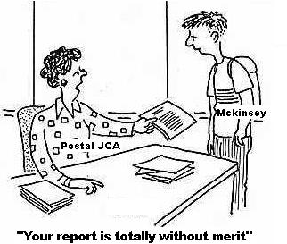
EXPECTED DA FROM JAN 2012
The moving of Dearness Allowance with the guidelines of AICPIN is shown as in the above table, the statistics for the month of December is still waiting to calculate the exact percentage of Dearness allowance for Central Govt employees and Pensioners… probably the Dearness allowance will be enhanced by 7% at this moment.

Jun-11 | 189 | 2203 | 183.58 | 67.82 | 58.59 | 58
Jul-11 | 193 | 2218 | 184.83 | 69.07 | 59.67 | 59
Aug-11 | 194 | 2234 | 186.17 | 70.41 | 60.82 | 60
Sep-11 | 197 | 2252 | 187.67 | 71.91 | 62.12 | 62
Oct-11 | 198 | 2269 | 189.08 | 73.32 | 63.34 | 63
Nov-11 | 199 | 2286 | 190.50 | 74.74 | 64.56 | 64
Dec-11 | Expected |  |  |  |  | 65
﻿

MAY ALL YOUR WISHES COME TRUE WITH OUR WISH
HAPPY NEW YEAR


