28/04/2014

Cadre Resructuring Committee agreement & Unions statement‏
Click here to see the details
﻿26/04/2014
Replay to 7th CPC Questionnaire.
Dear colleagues,
7th CPC Secretary sought views from our federation on 7th cpc Questionnaire please send your views to federation before 2nd May 2013.
7th cpc Secretary letter
7th CPC Questionnaire
http://7cpc.india.gov.in/7cpc_questionnaire.pdf.
Click above link to see details﻿
2)Appeal to our FNPO affiliated Division/Branch secretaries only 4 days are remain to submit Membership declaration to your the Head of the division.
FNPO Federation is targeting to increase at least 5% increase for each affiliated union .
Don’t forget expect you no one can do this. without your cooperation we cannot achieve this goal .
Our federation hopes and trusts you will help us to reach our target﻿﻿.
CLICK HERE TO DOWN LOAD AUTHORISATION FORM
Click here to down load NUGDS Authorisation ﻿
Last date of submitting declaration is 30th April , 2014﻿
25/04/2014
1)HON’BLE MINISTER FOR RAILWAYS SH. MALIKARJUN KHARGE HAS WRITTEN A DO LETTER TO MINISTER FOR FINANCE FOR ABOLISHING NEW PENSION SYSTEM (NPS) FROM INDIAN RAILWAYS.
Click here to see letter
24/04/2014
1)Core Banking Solution (CBS) FAQ Click here to see
23/04/2014﻿
FNPO-JPGU leadership seminar held in Kolkata on 19th to 20 April 2014 . Brother Eichiito UNI Director in grated the seminar details of the seminar will be published in our sentinel .
Please click below link to see the video
https://www.youtube.com/watch?v=kAR0lLcubV8&feature=youtu.be﻿

22/04/2014
1)Our sincere thanks to NAPE-C Kerla circle for creating BlogSpot to help PA/SA aspirants .This BlogSpot provide all the material for examination to PA/SA aspirants.
Our branch secretaries are requested to inform this to PA/SA applicant living in your area . Click this link to go to pasaexamination2014.blogspot.in.
2) Agend for National council (JCM) Standing committe﻿.
CLICK HERE TO SEE DETAILS﻿
3)Payment of Conveyance Allowance to Deaf and Dumb employees at par with Blind and Orthopeadically Handicapped employees﻿
cLICK HERE TO SEE COPY OF THE ORDER
20/04/2014
1)6th CPC 7th CPC questionnaire comparsion
CLICK HERE TO SEE DETAILS
19/04/2014
Payment of Dearness Allowances to Gramin Dak Sevaks (GDS) at Revised raetes w.e.f. 01.01.2014 onwards
Click here to see the order﻿
17/04/2014
7th Pay Commission Report and the Need for Timeliness
﻿Click here to see the details
16/04/2014
SG FNPO PROGRAMME.
07/04/2014 – Bangalore.
15/04/2014 to 20/04/2014 KOLKATTA
28/04/2014 to 30/04/2014 NEW DELHI
﻿15/04/2014
25% increase in Allowances whenever DA goes up by 50% – Whether Separate Orders Needed ?
Click here to see the details﻿

Click here to see the Hindi Version of this website.
Click here to see the Tamil Version of this website

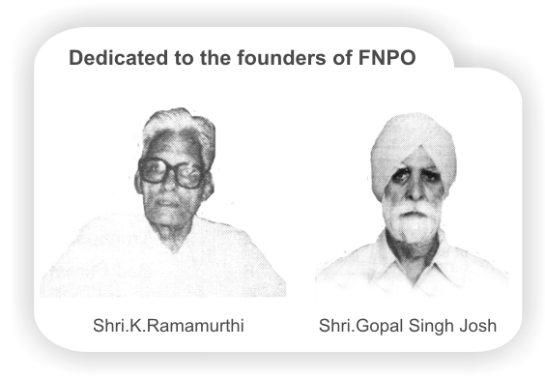

Affiliated union websites:
National Association of Postal Employees Group 'C'
NUPE Postmen & Group 'D'
Nugdsfnpo.web.com
www.fnpocivilwing.blogspot.in
www.nupegckar.blogspot,com.﻿
www.fnpokerala.blogspot.com.﻿
napecjalandhar.blogspot.in
The Route with map, to any destination in the world by Air/Bus/Train
Just click on link below and proceed further.
http://www.rome2rio.com/

﻿

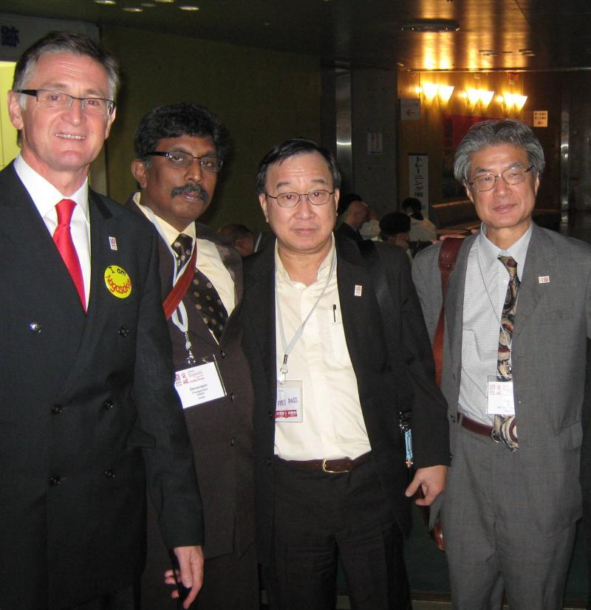

14/04/2014
﻿﻿
﻿﻿
HAPPY VISHU TO OUR VIEWERS
﻿
﻿
12/04/2014﻿
1)Delay in Government Inquiry No Bar on Promotion
2)Will LTC Air Travel Continue for the Next 2 Years?
CLICK HERE TO SEE THE DETAILS ﻿
11/04/2014
Appeal to our Divisional / Branch secretaries .
Enroll the new members who have joined the department after 2010/ willing members from other union to our FNPO Affiliated ﻿ unions
CLICK HERE TO DOWN LOAD AUTHORISATION FORM
Click here to down load NUGDS Authorisation ﻿
Last date of submitting declaration is 30th April , 2014.﻿
10/04/2014
1)Conduct Rules ppt
2)CCS(CCA) Rules ppt﻿﻿
09/04/2014
1)FNPO Affilated unions General secretaries meeting
2)D.A toCentral Govenment Pensioners.
Click here to see above in details
08/04/2014
1)FREQUENTLY ASKED QUESTIONS ON GRIEVANCE REDRESS MECHANISM IN
GOVERNMENT OF INDIA AND THE ROLE OF DEPARTMENT OF ADMINISTRATIVE
REFORMS AND PUBLIC GRIEVANCES,
Click here to see above in detail
2) 22nd Meeting of postal sports board held at kochi on 10/03/2014
CLICK HERE TO SEE DETAILS. ﻿

﻿

3)UPU E-Commerce Forum: It's springtime for Post ending the letter mail blues!﻿﻿
4)Cadre Restructuring Committee Meeting is Scheduled to be convened on 28/4/2014 at 1100 AM
5)To
All General Secretaries
NFPE & FNPO
Central JCA Meeting (NFPE & FNPO) will be held on 25thMay 2014 (Sunday) at 05.00 PM at NFPE office New Delhi. All General Secretaries are requested to attend the meeting in time.
D. Thegarajan M. Krishnan
Secretary General Secretary General FNPO NFPE﻿

06/04/2014
1)Post Bank of India: a missed opportunity for UPA-II﻿﻿
Why was the most eligible candidate excluded? Anyway the RBI has a mind of its own and has apparently not given into the government’s indifference. It has kept the option of the Postal Bank open and will follow up with the financial ministry. How long will the ministry block it? Will the next government take a favourable decision? The reasons are certainly more than what meets the eye.
Read more at: http://www.firstpost.com/india/why-rbis-decision-on-a-post-bank-of-india-is-a-slap-for-finance-ministry-1464349.html?utm_source=ref_article
Why was the most eligible candidate excluded?
Anyway the RBI has a mind of its own and has apparently not given into the government’s indifference. It has kept the option of the Postal Bank open and will follow up with the financial ministry.
How long will the ministry block it?
Will the next government take a favorable decision?
The reasons are certainly more than what meets the eye.
﻿
Why was the most eligible candidate excluded? Anyway the RBI has a mind of its own and has apparently not given into the government’s indifference. It has kept the option of the Postal Bank open and will follow up with the financial ministry. How long will the ministry block it? Will the next government take a favourable decision? The reasons are certainly more than what meets the eye.
Read more at: http://www.firstpost.com/india/why-rbis-decision-on-a-post-bank-of-india-is-a-slap-for-finance-ministry-1464349.html?utm_source=ref_article
2)Why RBI's decision on a Post Bank of India is a slap for ...﻿﻿
3) Children Education Allowance Scheme Clarification﻿
﻿
04/04/2014
1)Royal Mail’s ‘ruthless’ job cuts could provoke industrial action - Unite﻿﻿

2)Sale of Royal Mail is a taxpayer tragedy﻿
3)Friends... Here is the list of some books which will be helpful for Postal/Sorting AssistantExam 2014 preparation...﻿﻿
1) Guide to Postal Assistant/ Sorting AssistantExam 2014
Author: Disha Experts Rs. 156
Details>> http://goo.gl/oacle5
2) 15 Practice Sets - Department of Posts Postal Assistants / Sorting Assistants Recruitment Exam 1st Edition
Author: Arihant Experts Rs. 90
Details>> http://goo.gl/gZzJnY
3) Department Of Posts (Postal Assistant / Sorting Assistant) PostalAssistant Recruitment Exam Practice Work Book With Study Material
Publisher: Kiran Prakashan (2014) Rs. 128
Details>> http://goo.gl/Vx2pyc
4) Department of Posts POSTAL/SORTING ASSISTANT 2014 Recruitment Examination 2014 (Solved 2013 Entrance Paper) (English)
Author: GKP Rs. 190
Details>> http://goo.gl/Lw0AyV﻿
03/04/2014.﻿﻿
1)Guidelines for providing facilities to persons with disabilities who are already employed in Government for efficient performance of their duties.
Click here to see details.
02/04/2014.﻿
Click below link to see the details.
1)Processing of case under Rule 9...............
2) Declaration of holiday on 14th April 2014 Dte order
3)Indian consumers are opening up their wallets, making investments lucrative for foreign companies﻿.
4)India growth story marred by disturbing inequity﻿.
01/04/2014.
DA ORDER ISSUED BY DIRECTORATE CLICK HERE TO SEE ORDER ﻿
30/03/2014
﻿
APPEAL TO BRANCH/ DIVISIONAL SECRETARIES.
Enroll new members/Non members/ willing other union members to our FNPO Affiliated ﻿ unions
CLICK HERE TO DOWN LOAD AUTHORISATION FORM
Click here to down load NUGDS Authorisation
Amendments in PLI Rule 2011
﻿

Click here to see the Hindi Version of this website.
Click here to see the Tamil Version of this website


Affiliated union websites:
National Association of Postal Employees Group 'C'
NUPE Postmen & Group 'D'
Nugdsfnpo.web.com
www.fnpocivilwing.blogspot.in
www.nupegckar.blogspot,com.﻿
www.fnpokerala.blogspot.com.﻿
napecjalandhar.blogspot.in
The Route with map, to any destination in the world by Air/Bus/Train
Just click on link below and proceed further.
http://www.rome2rio.com/

﻿

