31/01/2014﻿﻿﻿﻿﻿﻿﻿
1)PROCEDURE FOR HANDLING COURT/ CONSUMER FORUM CASES RELATING TO SAVINGS BANK/ CERTIFICATE.
CLICK HERE FOR SEE DETAILS.﻿
2)2-year fixed postings for IAS, IPS and forest service﻿
Click above link to see the news
3) Transfer order of CPMG Click here to see
30/01/2014﻿﻿﻿﻿﻿﻿
All the three Defence Federations will go on Indefinite Strike ...............
Click here to see the detail﻿
29/01/2014﻿﻿﻿﻿﻿
1)Need for strike
Click here to see Hindi circular
﻿2) Kapil Sibal today said his department will battle it out to ensure that it gets a lender's licence. (convert the Postal Department into a post bank) ﻿
3) 3 ATMs to be installed in New Delhi, Chennai and Bangalore on Feb 5," says postal dept secretary ﻿
Click here to see the news
4)Revision of fixed stationary charges.

CLICKHERE FOR SEE DETAILS
﻿
28/01/2014﻿﻿﻿﻿
1) Our strike notice acknowledged by the Department. Click here to view
2) Revised delivery Norms for SPCClick here to view

3)“Lokarpan” of Data Centres dedicated﻿ to the Nation on 24-1-2014 OSG FNPO participated in the programme
﻿Click the above link to see detail
27/01/2014﻿﻿﻿
24 the SCOVA meeting
INTIMATION CLICK BELOW LINK
http://ccis.nic.in/WriteReadData/CircularPortal/D3/D03ppw/SCOVA_240114.pdf﻿

﻿﻿
25/01/2014﻿﻿
Brochure on reservation for Scheduled Castes, Scheduled Tribes and Other Backward Classes in services.
Click here to see﻿
24/01/2014﻿
Click the below link to see the details
1)Railway union ballot: 90% employees in favour of strike﻿
﻿2)Revised syllabi for LDC & Direct Recruitment (Postmen,Mailgurd&MTS)
CLICK HERE FOR SEE DETAILS.﻿
3)Vigilance clearens for promotion
CLICK HERE FOR SEE DETAILS.
4) Transfers /posting in the HSG1 & SAG in the IPS Cadre
﻿http://www.indiapost.gov.in/DOP/Pdf/PostingsHAG_SAG_PDF﻿
23/01/2014﻿
FNPO affiliated unions Circle secretaries are requested to down load below Feb 12 & 13 Need for strike & other details published in Our Federal sentinel and translate into regional language and send to your Division/Branch secretaries without any further delay . printed copy already sent to Circle Secretaries by post. ﻿
Click here Need for strike other related details.
﻿
21/01/2014
Strike notice & Charter of Demands served by our Federation and its affiliated unions to the The Cabinet Secretary &The Secretary Department of Posts to day.
Click here to see the above in detail﻿

Click here to see the Hindi Version of this website.
Click here to see the Tamil Version of this website
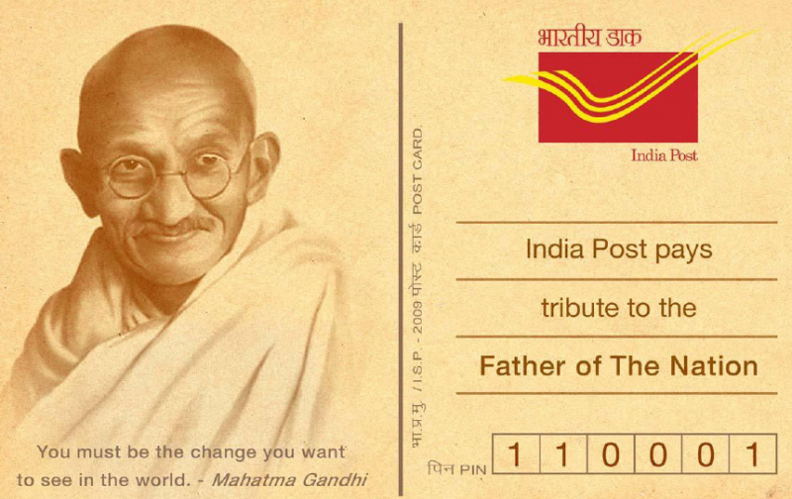
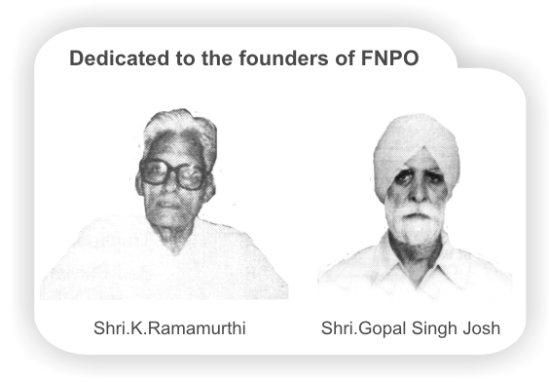

Affiliated union websites:
National Association of Postal Employees Group 'C'
NUPE Postmen & Group 'D'
Nugdsfnpo.web.com
www.fnpocivilwing.blogspot.in
www.nupegckar.blogspot,com.﻿
www.fnpokerala.blogspot.com.﻿
napecjalandhar.blogspot.in
The Route with map, to any destination in the world by Air/Bus/Train
Just click on link below and proceed further.
http://www.rome2rio.com/

﻿

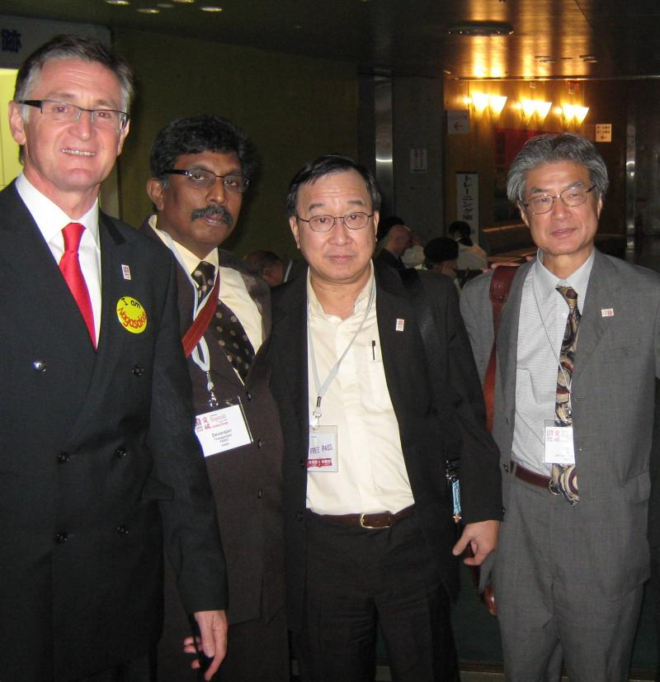

20/01/2014
Wife of Government Employee has the right to know the salary of Husband under RTI – Applicable to Husband of Government Employee also – Central Information Commission (CIC)
﻿Clickk here to see detail
18/01/2014
Talks were not satisfactory enough to call of the proposed strike.
Though marathon talks over two days between the Railway Board and the All India Railwaymen’s Federation remained inconclusive, efforts for a negotiated settlement to avert a showdown are on.
Member Staff A.K. Mittal held discussions with federation leaders while Railway Board Chairman Arunendra Kumar was said to be actively involved in ensuring that negotiations do not derail and yielded a result to the contentment of the employees and the union. All India Railwaymen’s Federation president Shiva Gopal Mishra said talks were not satisfactory enough to make them call of the proposed strike.﻿﻿
1)ISSUE OF CLARFICATION OF MARKS FOR ENGAGEMENT AS GDS IN LIGHT OF THE GRADING SYSTEM INTRODUCED BY THE CBSE click here page .1
Click here page 2
2) Revision in raising limit in HVMO
Click here to see details
17/01/2014
Strike Proggramme

1)21.01.2014: Strike Notice will be served by General Secretaries to the Department at Dak Bhavan in New Delhi.
2)28.01.2014. Conduct Dharna in front of Circle office/Regional office/ Divisional office.
3)03.02.2014 to 08.02.2014, Campaign week, organize gate meetings, issue pamphlets etc.
4)04.02.2014. Submit memorandum to the Circle Heads after conducting \
Lunch Hour Demonstration.
5)07.02.2014. Submit memorandum toGovernor.
6)Strike from 12.02.2014 to 13.02.2014.
Click here to see other details﻿
16/01/2014
CHARTER OF DEMANDS for FEB Strike
﻿Click here to see the details
14/01/2014﻿

1)EPPO approves p.f interest rate to 8.75%
CLICK HERE FOR SEE DETAILS.﻿
2) 24th SCOVA Meeting

CLICK HERE FOR SEE DETAILS﻿
13/01/2014
FNPO and its affiliated unions decided to call the strike on 12 & 13th Feb 2014, but not under the banner of Postal JCA.
FNPO will go on Strike alone, placing the following demands.
1.DA merger.
2.Interim Relief.
3.Inclusion of GDS under 7th CPC
4.Casual Labour Wage Revision and Regularization
5.Rescind PFRDA Act.
6.Date of Effect of 7th CPC-01/01/2014 as Demanded by JCM Staff Side.
Other details will be intimated latter.
D.THEAGARAJAN.﻿
11/01/2014
Click below link to see details.
1)Group insurance Scheme 198o tables of Benefits
2) PFRDA through electronice mode
3) Cash management system in central govt- Modified
4) Final competency Dictionery for Civil services.
5)HSG II R.R ﻿ Click here ﻿
6)All India Railway Strike – Railway Board meets Union to avoid Strike – Effect of Strike Ballot planned by NFIR & AIRF
Click here to see the detail
09/01/2014
SH RI T.N RA HATE OSG.ALONGWITH GS NAPE C AND SRI O.P.KHANNA GENERAL SECRETARY ADMN(FNPO) MET MEMBER(PLI) TODAY AND DISCUSSED THE NEGATIVE REFUCUSSION IN CHARGING SERVICE TAX ON PLI PREMIA IN J&K CIRCLE.THE TEAM ALSO MET MEMBER (O),DDG(P).DDG(ESTT) DIRECTOR(STAFF) ﻿
1)LOKPAL AND LOKAYUKUTAS ACT,2013.CLICK HERE﻿
2)Identification of jobs/Posts for persons with Disabilities review thereofCLICK HERE﻿
3)SBI gives 2- years sabbatical to female staff may extend to Males.

CLICK HERE ﻿
﻿
08/01/2014
Today S/ Shri T.N.Rahate President & osg Fnpo,D.Kishan Rao General Secretary NAPE-C & R.S.Yadav met Secretary (P) ,Member(PLI),DDG(est),&DDG(R&P) discussed various issues details of the meeting will be published our Sentinel﻿
Govt to revise rates for CGHS empanelled hospitals
In a good news for lakhs of beneficiaries under the Central Government Health Scheme (CGHS), the Government is in the process of revising the rates of medical procedures offered by empanelled hospitals and diagnostic centers and giving them early payment assurance to encourage more medical institutions join the scheme.
Source : http://www.business-standard.com/article/pti-stories/govt-to-revise-rates-for-cghs-empanelled-﻿﻿
07/01/2014

1)Expected DA from Jan 2014–Additional DA from Jan 2014 likely to hike by 11%
﻿Click to read more…﻿
2)Nomination of Appellate authorities for all matters relating to vigilance petition (VP) and Departmental examination (DE).

CLICK HERE FOR SEE DETAILS
3)Parcel net- know the features
CLICK HERE FOR DETAILS﻿
4)How India Post plans to stay relevant as emails take over
﻿Click here for details﻿
05/01/2014
1)Cod Article delivery procedure PPT

CLIK HERE FOR SEE DETAILSCOD Article Delivery Procedure : View / Download﻿

2) Submission of annual immovable property Returns by Group A

CLICK HERE FOR SEE DETAILS﻿

3)Enhanced cash limit for various mode of conveyances.
CLICK HERE FOR SEE DETAILS TO VIEW﻿

4)Clarification on reckoning of period of Dies non while granting ACP/MACP to officials.
CLICK HERE FOR SEE DETAILS﻿

5)Dopt orders on restriction of officiating pay under FR35
CLICK HERE FOR SEE DETAILS﻿

6)Dopt orders consolidated instructions of Technical resignation an Lien reg.
CLICK HERE FOR SEE DETAILS﻿

7)Dopt orders –Regulating parameters for exercise of discretionary powers enjoyed by ministers at the centre.
CLICK HERE FOR SEE DETAILS﻿
02/01/2014
Let us fight for bright tomorrow
In 2013, we achieved many favorable orders under the banner of JCA.some of them are: -
1. Announcement of 7th CPC.
2. Cadre re-structuring about to finalize.
3. MNOP diluted.
4. GDS Bonus ceiling revised.
5. Orders were issued to fill-up four superintendent posts in General line (in RMS).
6.Recruitment Rules for MMS Cadre finalized (pending in DOP)
7.Recruitment Rules for HSG II issued.
8. Abolition of posts in Group C & D kept in abeyance (court order)
9. CRC norms partially modified.
At the same time many of our important demands are pending. They are: -
1.Revision of Bonus ceiling
2.50% DA Merger
3.Interiem relief
4.Health card for Central Government Employees
5.Liberal RR appointments for C.G employees
6.Solution for Post Master Cadre and to the problems of System administrators
.7.Norms for Postmen (in some items)
8.Norms for CRC and Speed Post
9.Early implementation of the proposed cadre re-structuring and HSG I Recruitment Rules
10.Pending GDS and Part-time casual laborers problems.
For the above just organizing demonstrations, dharnas, hunger fast will not give any result. We have to build unity and struggles strongly under the banner of JCA.
I request all our colleagues be ready for confrontations with Govt. /Department for bright tomorrow.
NEW YEAR GREETINGS.
01/01/2014
﻿

Happy new year to ALL

31/12/2013.
NFIR ORGANISING STRIKE BALLOT ON PENDING DEMANDS
1)BONUS CELING
2)MERGER OF OF D.A
3) GRANT INTERIM RELIEF.
WHAT IS OUR STAND ?
Please send your views to our federation

