31/05/2017
REVIEW OF THE SCHEME FOR ENGAGEMENT OF A DEPENDENT OF DECEASED GDS ON COMPASSIONATE GROUNDS.(DOP ORDERS)﻿ Click here to view﻿
2)Expected Results Dates of Gramin Dak Sevak all states( 2017) it's Not Official It's me be Extendedview here. ﻿﻿
3) GDS | Minimum Cut off % | Some question answer view here|﻿
4)Cut Off % For Different States | GDS | Odisha Circle GDS Result Analysi﻿view here
﻿5)Selection Procedure for Gramin Dak Sevak | Merit List view here ﻿﻿

30/05/2017
Committee to Enquirer Serious Issues Against ST Employees Should Have Minimum of Two Members from ST Community Read more﻿ Read more﻿
﻿2)The stamp has been around since 1840, but production techniques have evolved considerably since that time. Learn all about the making of stamps and the secure features they often contain today to protect them against fraudClick here to view.﻿
3)Your online persona can land you a job where you ‘Belong Read more﻿
4)40 crore workers from unorganized sector to be covered under social security schemes: Shri Bandaru Dattatreya Read more﻿
5)Important Documents on Gandhi’s Assassination Missing from Official Records, Reveals RTI Read more﻿﻿
29/05/2017
"India Post Payment Bank"Airtel Payment Bank" "PayTM Payment Bank" ComparisonClick here to view﻿﻿
2)BSNL plans satellite phone service for all in 2 years Read more
3)Migration to 5G will be challenging for India: Experts Read more
4)Cognizant layoff plea closed in favor of sacked staff: Govt Read more
5)How Did Savarkar, a Staunch Supporter of British Colonialism, Come to Be Known as ‘Veer’?﻿ Read more﻿
28/05/2017
Govt open to strategic disinvestment in Air India: FM.Read more﻿
2)Three Years of Modi Management: The Numbers Don’t Tell a Good StoryRead more﻿.
3)Contrary To What The Govt Claims, Ban On Cattle Sale for Slaughter Will Affect Farmers Most Read more﻿﻿
27/05/2017

Gramin Dak Sevak Result 2017 GDS result GDS Merit list cut off ग्रामीण डाक सेवक all Circle Result 2017 Click here to know more.﻿
2)Applicability of Central Civil Services (Revised Pay) Rules, 2016 to persons re-employed in Government Service after retirement and whose pay is debitable to Civil Estimates/ Fixation of pay of State Govt.Employees on their appointment in Central Govt, subsequent to the implementation of CCS (Revised Pay) Rules,2016Click here to view
3)Implementation of Government's decision on the recommendations of the Seventh Central Pay Commission - Revision of pension of pre-2016 pensioners/family pensionersclick here to read﻿
4)Staff selection: Replace IBPS with regional recruitment boards, says bank bodyRead more﻿
5)Indian IT Is Not Down – But It Massive Job Creating Machine IsRead more﻿
6)Modi Report Card: Between Good and Satisfactory, But Best Is Yet To BeRead more﻿﻿

26/05/2017
India's Longest Bridge, Built For Tanks, To Open In Assam Today: 10 Facts Read more.﻿
2)GST rollout: Tea, milk powder, coffee to attract lower tax rate, set to get cheaper﻿Read more﻿
25/05/2017
Cadre Restructuring promotion orders were released at Tamil Nadu circle﻿Click here to view.﻿
2)Allotment of GPF Account Numbers to Casual Labourers with Temporary Status: DoP Order﻿Click here to view﻿
3)The Cabinet Secretary has fixed date of 1st June, 2017 for perusal of the report of the Allowances Committee by the Empowered Committee Click here to view..﻿
4)Fixing Very Good as Benchmark for granting MACP is not acceptable﻿ Click here to read﻿﻿
23/05/2017
No, Google’s Not a Bird: Bringing the Internet to Rural IndiaClick here to read﻿
2)With top IT firms laying off professionals, the IT-software industry was hit the most with a 24 per cent fall in hiring in April: Survey﻿Click here to read﻿
22/05/2017
OBSERVANCE OF SILENT DAY AGITATION BY OUR NATIONAL UNION OF POSTAL CIVIL WING EMPLOYEES﻿Click here to view.﻿
2)As lay-offs in IT industry rise, creating new jobs in the digital era will call for a new education systemRead more﻿
3)Fake Rs 2,000 notes printing racket busted in Dhaka; NIA suspects Pakistan linkRead more﻿﻿

21/05/2017﻿
Let us remember our youngest former Prime Minister Rajiv Gandhi on his death anniversary today .﻿
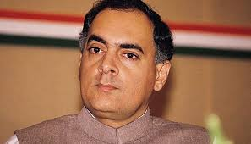﻿

20/05/2017
Regularise temporary status casual labourers.
Click here to view above letter.
2)Recommendations of 7th CPC on the benchmark for the purpose of MACPS-withdrawal of DoPT’s OM dt. 28.09.2016 is not feasible(clarification reg.) Click here to view
3)The Empowered Committee of Secretaries (E-CoS) is expected to convene next week to ponder on the 7th CPC recommendations before being presented before the Union Cabinet for their nod.Read more
4)How to rescue your PC from ransom-ware Read more
5)Pay Fixation in 7th CPC - Important Clarification on Promotion/MACP between from 01.01.2016 to date of notificationRead more
6)Admissibility of flexi fare/dynamic fare on performance of journey in Shatabdi /Rajdhani /Duronto trains: Clarification﻿Read more
19/05/2017﻿
Request to grant 7th CPC scale to the Temporary Status MTS﻿ ﻿
Click here to view above letter.﻿﻿
2)Directorate Instructions on Hardware failure or lost cases after migration to the new network﻿ Read more﻿
3) Cancellation of Postman/Mailguard Direct Recruitment Examination held on 11.12.2016 in TN Circle Read more﻿
﻿4) Conversion of Temporary posts in to permanent ones up to the level of Deputy Secretary in Ministries/Departments : DoP Order﻿ Click here to view﻿
18/05/2017

Integrated Index for Postal DevelopmentClick here to read more﻿
2)Dear Divisional Secretaries of FNPO affiliated Unions.
It is learnt that some of the DDOs are rejecting our declaration stating that letter of authorisation is not endorsed with SR's signature. Click here to view clarification issued by Directorate.﻿﻿
17/05/2017
7th CPC Revised Civilian Pay Matrix: Gazette Notification – Resolution dated 16.05.2017﻿Click here to view﻿
2)No 7th CPC Allowance then-No Agenda for NAC, the date fixed by DoPT should be postponed - Staff Side JCM ﻿Read more
3)Convene a staff side meeting to find a solution- Our letter to The Chairman PSB . Click here to view. ﻿
4)Complete formalities to implement cadre restructuring for S.A., MMS, PA CO, PA and SBCO cadres earlyClick here to view.﻿
5)Request to appoint a committee for CRC to left out Categories-﻿Click here to view
6)Pension Arrears Calculator as Per New Formulationclick her to view﻿
7)Family Pension Calculator based on New Option I by arriving Notional PayClick here to view﻿
8)Notional Pay and Pension Calculator as Per New Formulation﻿Click here to view
9)ALL PAYMENT TO GOVERNMENT SERVANTS THROUGH E-PAYMENT ONLY: AMENDMENT IN RECEIPT & PAYMENT RULESRead more

16/05/2017﻿
Modifications/changes in the MNOPClick here to view our letter.Click here to view our letter.﻿.﻿
2)Cyber-attack alert! Who is responsible? What is WannaCry ransomware? How can it affect India?Click here to read ans﻿
3)When even judges can't understand judgments﻿ Click here to read.
4)RBI asks taxpayers to pay dues in advance﻿To read click here.
﻿

“Forward ever, backward never: onwards with Breaking Through”﻿
Click here to see the Hindi Version of this website.
Click here to see the Tamil Version of this website

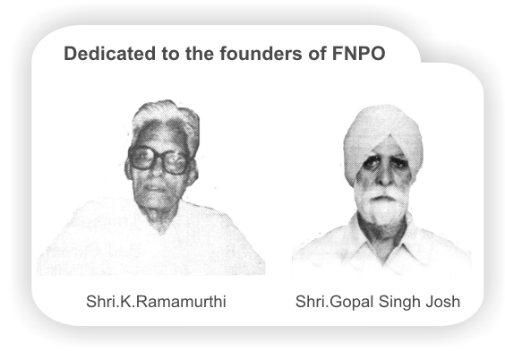

Affiliated union websites:
National Association of Postal Employees Group 'C'
NUPE Postmen & Group 'D'
Nugdsfnpo.web.com
www.fnpocivilwing.blogspot.in
www.nupegckar.blogspot,com.﻿
www.fnpokerala.blogspot.com.﻿
napecjalandhar.blogspot.in
The Route with map, to any destination in the world by Air/Bus/Train
Just click on link below and proceed further.
http://www.rome2rio.com/

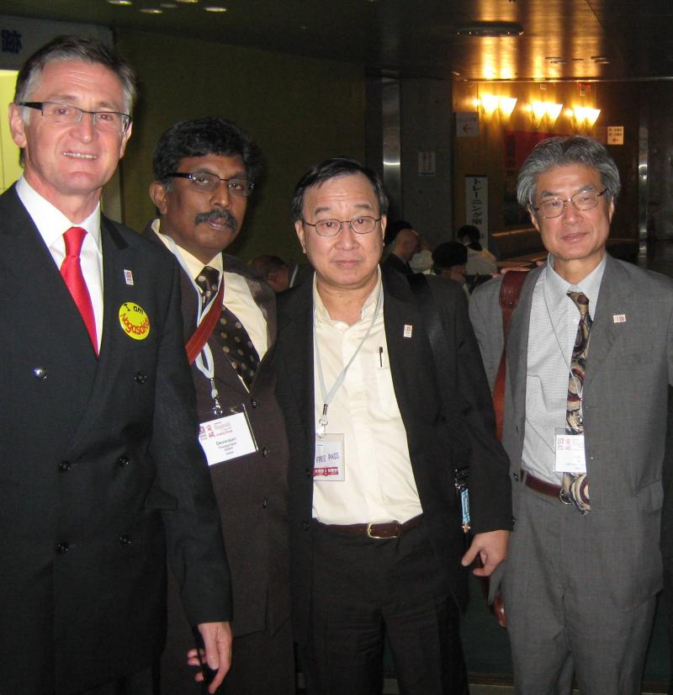
15/05/2017
DOP has taken the decision to block Google/Gmail and the Associated subdomains up to 18th May to start with﻿﻿Read more
2)IT dept launches online facility to correct errors in PAN and Aadhaar﻿Read more
3)The WannaCry ransomware attack has spread to 150 countries Read more﻿.
4)The charge of Director General Postal Service to the Senior most Member, PSB, Ms Meera Handa﻿﻿﻿Click here to View the order﻿

﻿
14/05/2017
Police suspect postal recruitment racket, during the preliminary investigation, had traced the location tower and identified the cell phone number used from Haryana..Read more﻿
2)Why Duplicate PAN Cards Are Not as Big an Issue as the Modi Government Claims Read more﻿.
3)India no longer needs global support to decarbonise itself: UNEP expert﻿Read more
4)Indira Gandhi remains most acceptable PM even 33 years after death: President Pranab Mukherjee﻿﻿Read more﻿

﻿
13/05/2017
Pension Fixation on Notional Pay in Pay Matrix – Pre 2016 Pension Revision Order IssuedPension Fixation on Notional Pay in Pay Matrix – Pre 2016 Pension Revision Order Issued Click here to view the order﻿
2)Income Tax (IT) Department simplifies linking PAN with Aadhaar for taxpayers using Income Tax India website.No need to login or be registered on the E-filing website for linkingClick here to view﻿
3)Date of next increment in cases where Govt servants are not able to Join posts in a particular grade pay on Promotion/appointment on 1st January of a year due to Sunday or Gazetted HolidayClick here to view﻿
4)Clarification regarding admissibility of flexi - fare in Shatabdi /Rajadhani / Duranto While availing LTC : DoP OrderClick here to view the order﻿﻿

12/05/2017
A note on HRA has been sent to Committee on Allowances by the JCM (Staff Side). Full text of note on HRA by JCM (Staff Side) is furnished﻿Read more﻿
2)Extension of time limit for forwarding of 7th CPC Anomalies for consideration in the National anomaly Committee: DoPT Order Click here to view order﻿
3)Malpractices in Postman & MailGuard Examination in Kerala-Circle Click here to view letter.﻿﻿
11/05/2017
The Supreme Court Order Sentencing Justice Karnan to Six Months’ Imprisonment Sets A Wrong PrecedentRead more﻿
2)After Narendra Modi’s infra push, about a quarter of 1,201 projects valued at Rs16.9 trillion were delayed as of January, down from 43% two years back﻿Read more﻿
10/05/2017
The Narendra Modi administration’s recent moves in healthcare demonstrate how failing to anticipate these consequences results in poor policiesRead more﻿﻿
2)Revision of guidelines for considering placement under TBOP/BCR SchemesClick here to view order of the Dte.﻿﻿
3)India’s manufacturing policy will soon be overhauled with the objective of creating more jobs in an environment where technology is rapidly replacing labour, commerce & industry minister Nirmala Sitharaman said on TuesdayRead more.﻿
09/05/2017
1)Narendra Modi government looks to carrot-and-stick policy to get rid of bad loans crisis﻿ Read more
Clarification on recently notified Maternity Benefit (Amendment) ACT, 2017﻿Click here to view
08/05/2017
While Pay Commission’s report is put on the Public Domain after its submission to the government, why these reports are kept secret”, the Staff Side asked﻿(Proceedings of the Standing Committee meeting of the National Council)Read more﻿'
2)Today SG FNPO met the Chairman Postal Board, Member (O) and Member (P).
Outcome of the meeting: Chairman agreed to convene staff side meeting shortly to finalise the issue of cadre restructuring. ﻿﻿
3) Little hike in fitment factor will make minimum wage rise substantially, will Modi Cabinet do it? - Read More
4) Cabinet approves modifications in pay structure, pay matrices :Financial ExpressRead More﻿
﻿07/05/2017
The Cabinet has now approved further modifications in the pay structure and the three Pay Matrices, i.e. Civil, Defence and Military Nursing Service (MNS). The modifications are listed below﻿Read more﻿
2)GST roll out: 10 goods and services that will become more expensive after July Read more﻿
3)Government plans lower I-T slab, free health check-ups for women Read more﻿
4)Banking Regulation Act: President likely ﻿promulgate an ordinance Read more
5)No one can build Aadhaar users' profile ﻿Read more﻿
06/05/2017
According to a report, the allowance committee has suggested minor modifications in some allowances that are applicable universally to all employees as well as certain other allowances which are applicable to specific employee categories﻿ Read more﻿
2)The biggest privacy risk is your smartphone-Read more
3)E-platform for govt staff soon to report sexual harassment ﻿Read more ﻿﻿
4)Flight tickets may get costlier as govt plans hike in passenger service fee﻿Read more
05/05/2017
7th CPC Allowances, Minimum Wages, multiplying factor, pension parity, MACP, Issues discussed in the Standing Committee Meeting of NC/JCM on 3rd May 2017﻿﻿Read more﻿
04/05/2017
The outcome of the standing committee held on 03/05/2017read more
2)REVISION/AMENDMENT IN RECRUITMENT RULES FOR THE POST OF POSTAL SERVICE GROUP 'BClick here to view﻿﻿﻿
03/05/2017
Cabinet approves modifications in the 7th CPC recommendations on pay and pensionary benefits﻿ modifications will be available with effect from 1st January 2016 ﻿Read more﻿
2)Since the November 2016 announcement that demonetised 86 per cent of India’s currency in circulation, Rs 5,400 crore (US$837 million) of undisclosed income has been detected.﻿Read more﻿

02/05/2017
FIXATION OF PAY OF RE-EMPLOYED PERSONS INCLUDING RE-EMPLOYED EX-SERVICEMEN Click here to Read more﻿
2)SC Should Know the Difference Between Unsound Mind, Mental Illness and ‘Bad’ Behaviour Read more
01/05/2017
Mayday greetings to our viewers.
2) VIP culture must end, says PM Now that red beacons have been removed, the mindset should also changeRead more﻿
3)Global pension funds scouting for deals in India's solar power sector ﻿Read more﻿

30/04/2017
International Labour Day 2017 will be celebrated by the people all over the world on 1st of May, at Monday.﻿READ MORE
2)IMPLEMENTATION OF MACP RETROSPECTIVELY W.E.F. 01-09-2008 AND DENYING PROMOTIONAL HIERARCHY UNDER ACP FOR THOSE WHO HAVE COMPLETED REQUIRED SERVICE DURING THE PERIOD BETWEEN 01-09-2008 TO 19-05-2009 HELD NOT LEGAL﻿Read more﻿

﻿

Copyright © 2011 ﻿FNPO | All rights reserved
FNPO
T-24, ATUL GROVE ROAD
NEW DELHI 110 001
India
ph: 011- 23321378
theagarajannachi@hotmail.com

