30/11/2012
On 29.11.2012 periodical Meeting was held under the Chair of Secretary (P).
The following subjects were discussed during the meeting.
Click here to see the briefs on agenda﻿
﻿On 30.11.2012 Member(T) conducted a meeting on IT Modernization Project in Post offices. FNPO was represented by Secratary General & General Secrataries of FNPO affiliated unions. Details of the meeting and our veiws will be published in our sentinel.
After the meeting president FNPO and SGFNPO met the follwing officers
a) Member(O)
b) Member(P)
c) CGM (MB)
d) DDG( Esttablishment)
e) Director ( Staff)
Outcome of the Meeting:-
1. Officers agreed to conduct the meeting with RMS General Secrataries on AMPC issues
2.Irregular Postings made in LSG Cadre - Report will be called for from circles.
3.Norms for Post Man : Seperate meeting will be conducted under the CGM MB with Secratray Generals of two federations & General Secrataries﻿
27/11/2012.﻿﻿﻿
Programme of SG FNPO.﻿
Periodical meeting ﻿ON 29/11/2012.
MEETING ON CHANGE MANAGEMENT PROCES UNDER INDIA POST 2012 WITH Member (Tech) on 30/11/2012.
01/12/2012-- AMPC Delhi Visit
26/11/2012.﻿﻿
Walmart’s growing global crisis
Click here to Read more... ﻿
24/11/2012.﻿
Reservation in promotion to SCs and STs: Latest statement by Minister of Personnel
﻿ Appointment in Government service using Fake Caste Certificates ﻿.
The Cabinet Committee on Economic Affairs approved the proposal of Rs.4,909 crore towards IT modernisation project of the Department of Posts, covering 1.55 lakhs post offices.
Click this link to see the details.
23/11/2012.
On 22/11/2012, SG FNPO Met the following officers.
Member (Tech) and CGM (MB)
Latest developments.
Cadre Restructuring: Meeting will be held shortly.
Gds issues: No improvement.
LGO Result: Result will be declared 1st week of December 2012.
Periodical meeting : Will be held on 29/11/2012.
On 21/11/2012 SG FNPO Met Chief PMG Rajasthan along with Shri Jolasing NUPM &MTS Circle secretary and discussed various issues of Rajasthan circle details will be published in our sentinel
RR For Deputy Manager,Manager and Technical superviser in the centre for excellence in Postal Technology .
Click here to see the R.R
Black Friday: Sponsor a striking US Walmart worker ﻿
Read more...
19/11/2012.
Today SG FNPO met Chief PMG of J&K Circle along with NAPE-C Circle Secretary Shri. F.A.Reshi and NUGDS Circle Secretary Shri. Ab. Majid and discussed various issues of J&K Circle. The meeting lasted more than an hour. Details will be published in our sentinel.

17/11/2012.
CPAO calls for details of pensioners and family pensioners in the Pension Life Certificate Click here to see the detais.﻿
16/11/2012
Travelling Allowance applicable to Central Government Employees- A re-visit
Click here to see the details

12/11/2012
DIWALI GREETINGS TO ALL OUR VIEWERS
11/11/2012.
Programme of SG FNPO.
12/11/2012 to16/11/2012--World executive board meeting at Geneva.
18/11/2012 to 19/11/2012---Srinagar (J&k) Private visit.)
20/11/2012--- NewDelhi.
21/11/2012Jaipur (Private visit)
22/11/2012NewDelhi.
Click below link to see the details
UIDAI launches Public Data Portal forAadhaar.
Recogintion of Chaitanya Hospital O.M.
10/11/2012.
RPLI Revised Rate of Bonus
Scholarship / Merit Scholarship to SC / ST / OBC / Min. Students studying in classes I-XII for the year 2012-13
Click here to see details
08/11/2012.
1)Clarifications regarding the action to be taken to fill up the vacancies of MTS, Postmen,Mailgurd.
click here to see the clarifications issued to Heads of circles.
2)Central Administrative Tribunal (CAT) says the employee should be reinstated as the disability occurred during the course of employment
3)ON LINE DOCTOR!
4)Central Government Residential Colonies Nomination of Area Welfare Officers for the calendar years 2013 and 2014
5)Transfer Lower post under FR 15(a) : DoPT Order lo
click this link to see the details.
06/11/2012.
Japan Government announces intention to sell two-thirds of shares of holding company.
click here to Read more...
05/11/2012.
Comprehensive review of instructions pertaining to vigilance clearance for promotion.
UNI APRO BULETIN
WORLD POSTAL NEWS.
04/11/2012.
Member (O) called meeting on 02/11/2012 to discuses L1&L2 issues with staff side. Staff side was represented by SG FNPO, SG NFPE &Staff side leader.
The following issues were discussed .
1) Transfer of officials from L2 offices to L1 offices.
2) Conversation of more L2 offices in to L1.
3) Stop merger/closure of sets .
4) Filling up all Norm based posts LSG,HSG II,HSG I Posts.
5) Changing the administrative jurisdiction of all speed posts hubs to RMS.
Official side has not given any positive reply ,details of the meeting will be published our RMS SENTIENEL.
SG FNPO Met DDG (esst), Director (staff) Director(M.V.) out come of the meeting.
Cadre restructuring : Report will be submitted by the chairman within 2 weeks.
MMS Cadre restructuring : Report will be submitted to the Secretry next week by the Chairperson .
Filling up the HSG I Posts: RR will be finalized soon.
GDS issues: No improvement.
Casual Laborers issues: Official side will call meeting shortly to discuss the issues with 2 Federations.
Secretary Department of Posts given approval absorb all the Temporary Casual Laborers of Chennai sorting Division and Chennai Airmail sorting Division based Madras High court judgment. Orders will be issued to the Tamilnadu circle next week by the Directorate.
03/11/2012.
click the below link to see Dharan news in Kerla circle. Mass dharna held at Divisional Headquarters
02/11/2012 .
Meeting with Member (O)
Click here to see the details.
Global unions tell Turkeys President new labour law is unacceptable CLIIK BELOW LINK TO Read more... .
01/11/2012
1) Removing certain anomalies in its career progression scheme, the Central government has ordered stepping up of pay of employees in cases where a senior is getting lower emoluments than his junior.
2) SALIENT FEATURES OF EXISTING TATKAL SCHEME .
Click here to see the abve in detail
SCHEME FOR PAYMENY OF PENSIONS
TO POSTAL PENSIONERS THROUGH
NATIONALISED BANKS
CLICK HERE TO SEE THE SCHEME.

Click here to see the Hindi Version of this website.
Click here to see the Tamil Version of this website
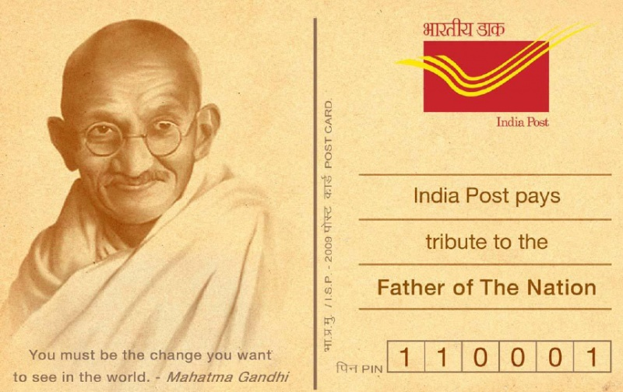
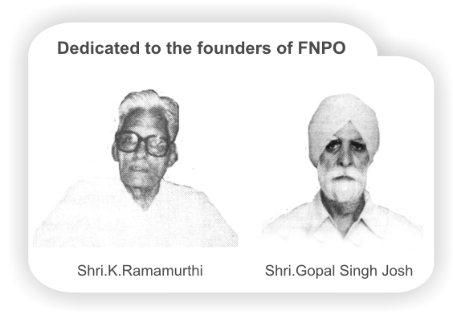

Affiliated union websites:
National Association of Postal Employees Group 'C'
NUPE Postmen & Group 'D'
Nugdsfnpo.web.com
www.nupegckar.blogspot,com.﻿
www.fnpokerala.blogspot.com.﻿
napecjalandhar.blogspot.in
Post Office Manuals
- BO Rules
- FHB Volume 2
- INDIAN PO ACT 1898
- Inspection of BOs
- Inspection of HPOs
- Inspection of SOs
- PLI Rules - 2
- PO Guide Part I
- PO SB Act
- PO SC Act
- POSB Manual Volume - 1
- POSB Manual Volume - 2
- POSB Manual Volume - 3
- Postal Accounts Volume - 1
- Postal Accounts Volume - 2
- Postal Manual Volume - 2
- Postal Manual Volume - 3
- Postal Manual Volume - 4-1
- Postal Manual Volume - 4-2
- Postal Manual Volume - 5
- Postal Manual Volume - 7
- Postal Manual Volume - 8

Conduct & CCA Rules
- CCS [CCA] Rules 1965 On Advice of UPSC
- CCS [CCA] Rules 1965
- CCS [Conduct] Rules 1964

Useful Links

- India Post;
- PTC;
- World Postal Info
- International Postal Admins
- Ticket reservations for Air, Train, Bus,
- Tour Packages
- International Organisations; Education;
- Search Engines
- Shopping
- News/ Entertainment;
- Travel
- Art
- Music;
- Pension
- Retirement benefits etc.

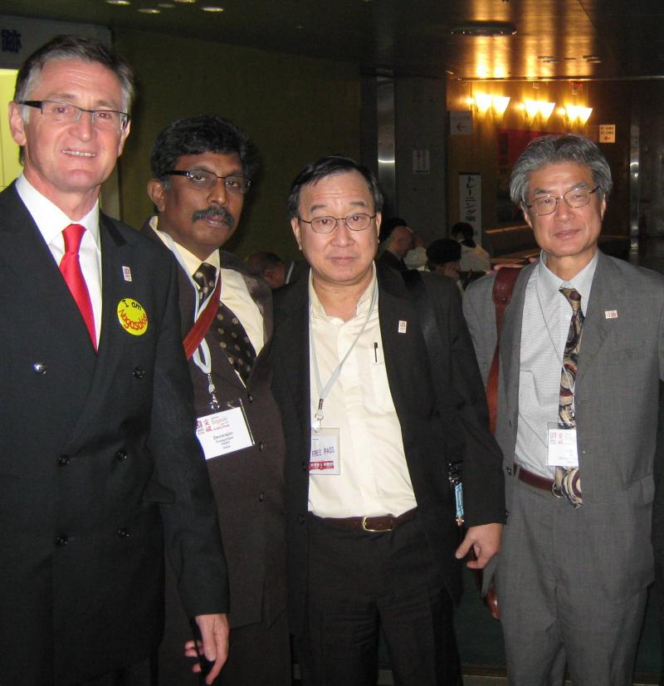

Copyright © 2011 ﻿FNPO | All rights reserved
FNPO
T-24, ATUL GROVE ROAD
NEW DELHI 110 001
India
ph: 011- 23321378
theagarajannachi@hotmail.com

